Shirley (Jacob) Bourgeois

September 4, 1945 – December 19, 2010

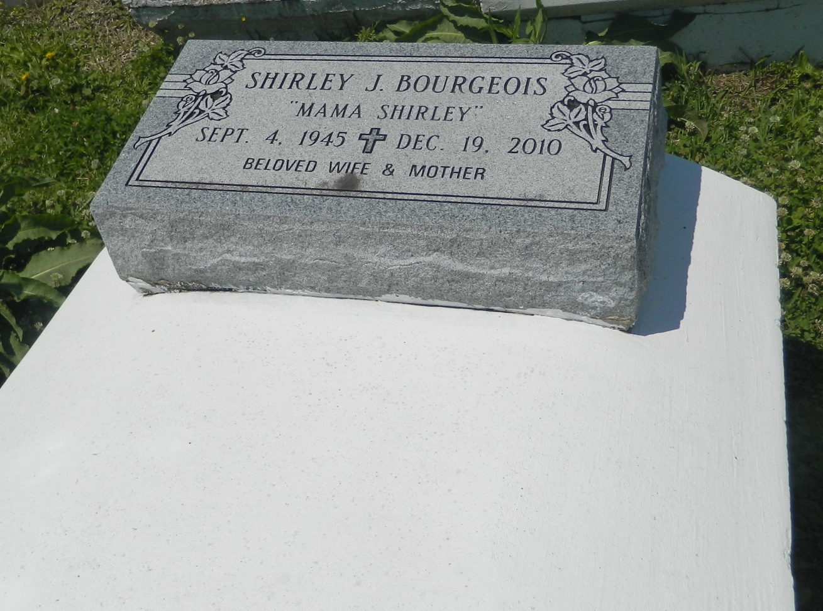

Shirley A. Bourgeois "MaMa Shirley" on Sunday, December 19, 2010 at Ochsner Medical Center of Kenner, Kenner, LA. Daughter of the late Morgan and Dorothy Jacob. Wife of Wallace Bourgeois. Mother of Felicia (Guy) Charles, Felencia, Wallace, Jr. and Felinda Bourgeois. Sister of Gilbert Duhe, Lucien Jacob, Sr., Velma Clay, Manuel Jacob, Lionel Jacob, Carmen Jacob, Vanessa Noble, Pastor Alfreda Devare, Latricia Miles and the late Marvin Jacob. Also survived by 10 grandchildren, 4 great grandchildren and a host of nieces, nephews, other relatives and friends. Age 65 years. A native and resident of LaPlace, LA.  
  
Relatives and friends of the family, also priests and parishioners of Our Lady of Grace Catholic Church and all neighboring churches are invited to attend the Mass of Christian Burial at Our Lady of Grace Catholic Church, 772 Hwy 44, Reserve, LA, on Friday, December 24, 2010 at 11:00 PM. Fr. Joseph Rodney, Celebrant. Interment: Bethlehem Cemetery, Reserve, LA. Visitation at the above named church from 9:00 AM until Mass time.  
  
SERVICED BY ROBOTTOM

**Times-Picayune, The (New Orleans, LA) - Thursday, December 23, 2010**

**Contributed by Jane Edson**