Barry Clark

January 10, 1962 – August 16, 2011

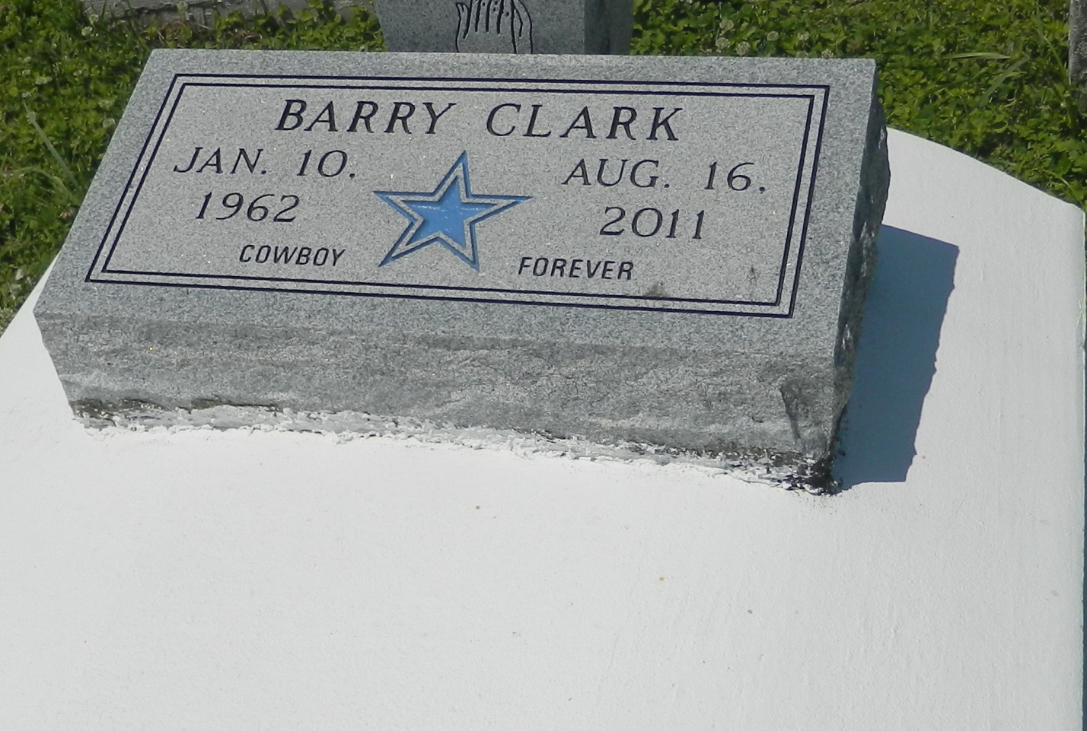

Barry Clark, age 49, departed this life on Tuesday, August 16, 2011 in Kenner, La. Son of the late Annie Penn and Earl Clark, Sr. Brother of Earl Jr., Edward, Wilfred, Johnny and Rose Clark, the late Gregory, Marilyn and Charles Clark. Also survived by 5 sisters-in-law, 9 nieces, 7 nephews, and cousin.  
  
Service will be held at Milesville Memorial C.O.G.C., 129 Apple St., LaPlace, La. on Saturday, August 20, 2011 at 11:00 a.m. Interment in Bethlehem Cemetery, Reserve, La. Visitation will begin at 5:00-7:00 p.m. on Friday at the Church and on Saturday from 8:00 a.m. until service time, (ONLY). Bishop Ronald Frank, Pastor - Officiating.  
  
Services Entrusted to Hobson Brown Funeral Home, Garyville, La 70051; (985) 535-2516

**Times-Picayune, The (New Orleans, LA) - Friday, August 19, 2011**

**Contributed by Jane Edson**