Martha J. (Mitchell) Coco

July 11, 1960 – November 3, 2010

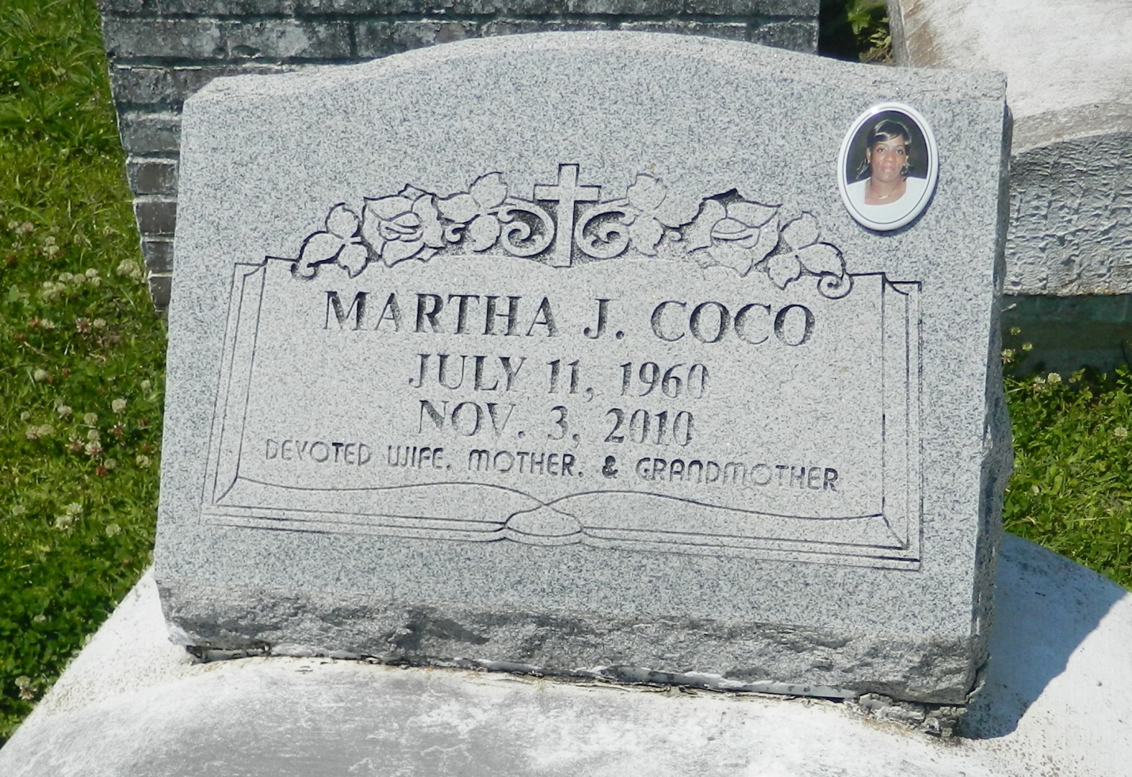

Martha Mitchell Coco departed this life on Wednesday, November 3, 2010 in LaPlace, LA, at the age of 50. A native of Reserve, LA and resident of Maurepas and Prairieville, LA. Survived by her husband, Eddie Coco; mother, Eva Joseph; 6 children, 10 step-children; 3 godchildren; and a host of grandchildren, aunts, uncles, nieces, nephews, cousins, and friends.  
  
Funeral Service will be on Saturday, November 13, 2010 at Riverlands Christian Center, 480 NW 3rd St., Reserve LA, at 11:00 a.m. Rev. Steve Perrilloux Pastor, Officiating. Visitation on Friday, November 12, 2010 from 5:00-7:00 p.m. at the Church, Reserve LA. Interment in Bethlehem Cemetery. Reserve, LA.  
  
Professional Service Entrusted to Hobson Brown Funeral Home, Garyville, La 70051;   
(985) 535-2516

**Times-Picayune, The (New Orleans, LA) - Friday, November 12, 2010**

**Contributed by Jane Edson**