Troy Dropthmore

September 6, 1969 – February 13, 2010

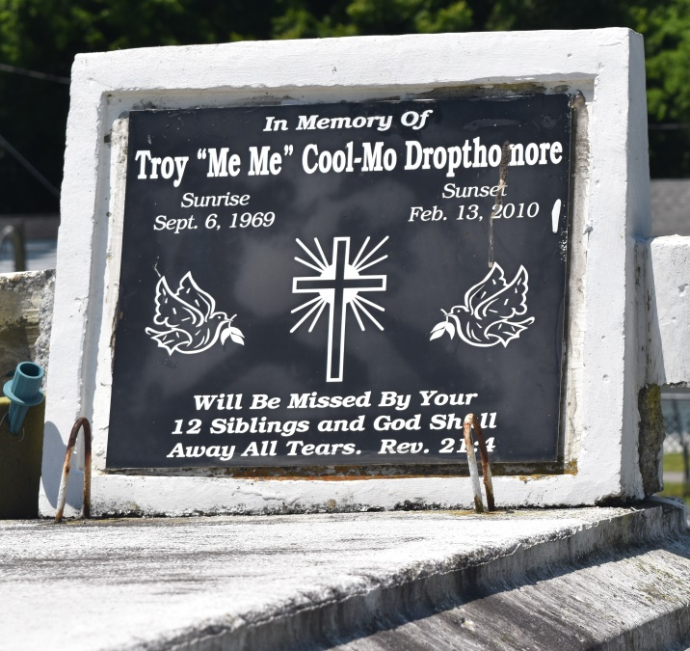

Troy "MeMe" "Cool Mo" Dropthmore departed this life on Saturday, February 13, 2010 in LaPlace, La. Son of the late Dorothy Baker and the late Willie Morris, and stepson of Sarah Lee Morris. Brother of Curtis Francois, Kerry, Michael, and Larry Baker, Donald, Richard, Louis, Cornela, Ronald and Alma Dropthmore, Cheryl Nicholson, Robert Shinard, Monica Gray, Brandon McGee Gregory Morris, and the late Jerry Morris. Nephew of Herbert and Pearl Baker, Doris Robinson, and Margret Harper. Also survived by a host of nieces, nephews, other relatives and friends. A native and resident of LaPlace, La.  
  
Service will be Saturday, February 20, 2010 at Mt. Calvary B.C., 127 W. 3rd, LaPlace, La., at 12:00 noon. Relatives and friends and all neighboring churches, employees of Cargill Grain Elevator, Pala Interstate Shell Norco, Department of Transportation & Development, Hilton Millet Concrete, Allied Barton Security, and Wendy's Hamburger in Florida are invited to attend the Funeral Service at the above named church. Rev. Dr. Freddie Howard., Pastor - Officiating. Burial in Bethlehem Cemetery, Reserve, La. Viewing at the Church on Saturday from 11:00 a.m. until service time.  
  
Professional Service Entrusted to Hobson Brown Funeral Home, 134 Daisy St., Garyville, La.  
(98) 535-2516

**Times-Picayune, The (New Orleans, LA) - Friday, February 19, 2010**

**\*\*\*\*\***

A LaPlace man has pleaded guilty to manslaughter in a 2010 shooting in LaPlace.  
  
 Joseph Noble, 20, entered his plea on Monday before 40th Judicial District Judge Mary Hotard Becnel and was sentenced to 15 years with the Department of Corrections without the benefit of probation or parole. Noble was accused in the Feb. 13, 2010, shooting of 40-year-old **Troy Dropthmore** in LaPlace. Noble and Dropthmore, who were acquaintances, were arguing just before the fatal shooting, according to authorities. When deputies arrived, they found Dropthmore on the front lawn of an apartment in the 200 block of Joe Parquet Circle with multiple gunshot wounds. Authorities located the gun used in the shooting after receiving a tip about its location. Noble admitted shooting Dropthmore, according to the St. John the Baptist Parish district attorney's office.  
 "I wish to thank a concerned citizen who was instrumental in providing the Sheriff's Office with information that assisted in solving this crime," District Attorney Tom Daley said in a news release.  
  
**Times-Picayune, The: Web Edition Articles (New Orleans, LA) - Friday, August 24, 2012**

**Both contributed by Jane Edson**