Sheila (Johnson) Johnson

September 13, 1955 – March 7, 2006

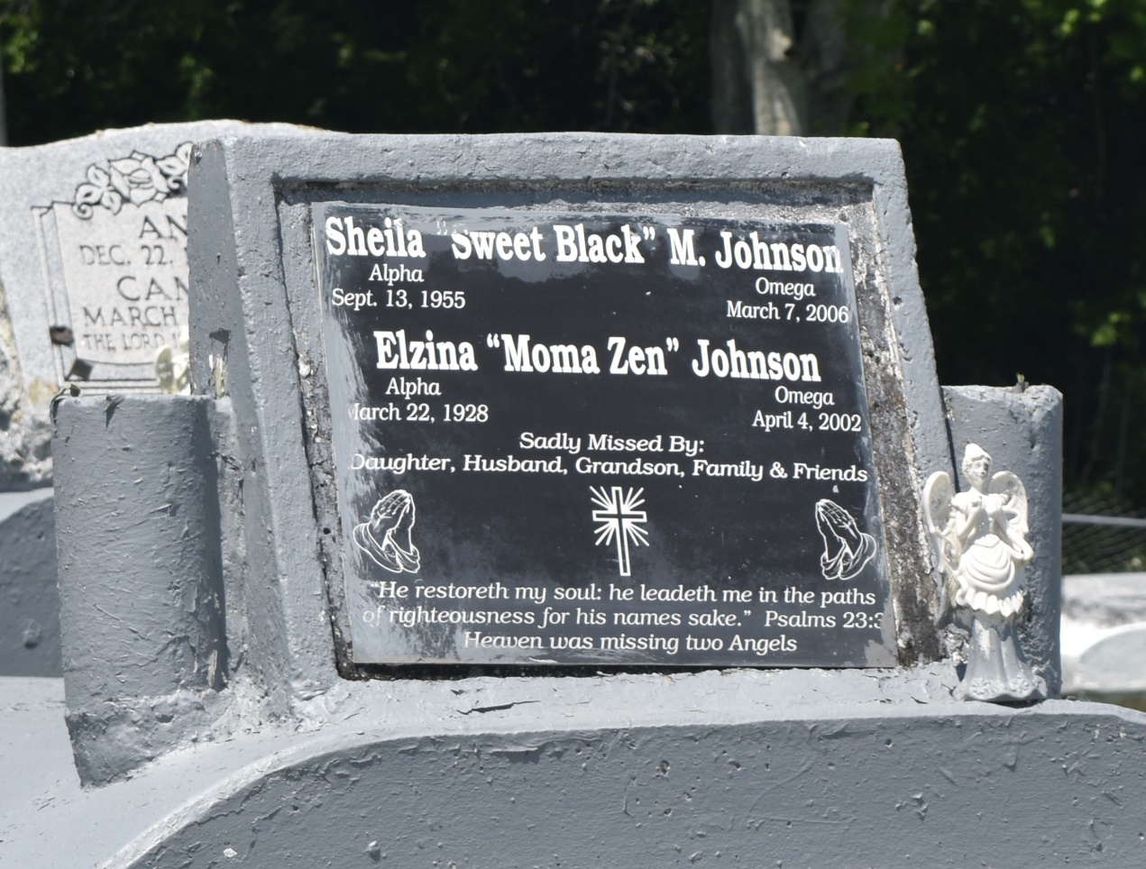

Shelia (Sweet Black) Johnson departed this life on Tuesday, March 7, 2006, at River Parish Hospital, Reserve, La. Daughter of the late Wilbert and Elzina Johnson. Wife of Wilbert Johnson. Mother of Elzina Jenkins. Also survived by a (1) step-son, (2) sisters, (1) brother, (1) grandchild, nieces, nephews, aunts, uncles, other relatives and friends. Native and resident of Reserve, LA. Age 50.  
  
Pastor, officers, and members of Milesville Memorial Church of God in Christ, and all neighboring churches are invited to attend the Homegoing Service on Saturday March 11, 2006 at 11:00a.m at the above named church, 129 Apple St., LaPlace, La. Bishop Ronald Frank, Pastor, Officiating. Interment in Bethlehem Cemetery, Reserve, La.  
  
Services entrusted to HOBSON BROWN FUNERAL HOME, Garyville, LA.

**Times-Picayune, The (New Orleans, LA) - Friday, March 10, 2006**

**Contributed by Jane Edson**