Annie Mae Jones

December 22, 1948 – September 10, 2004

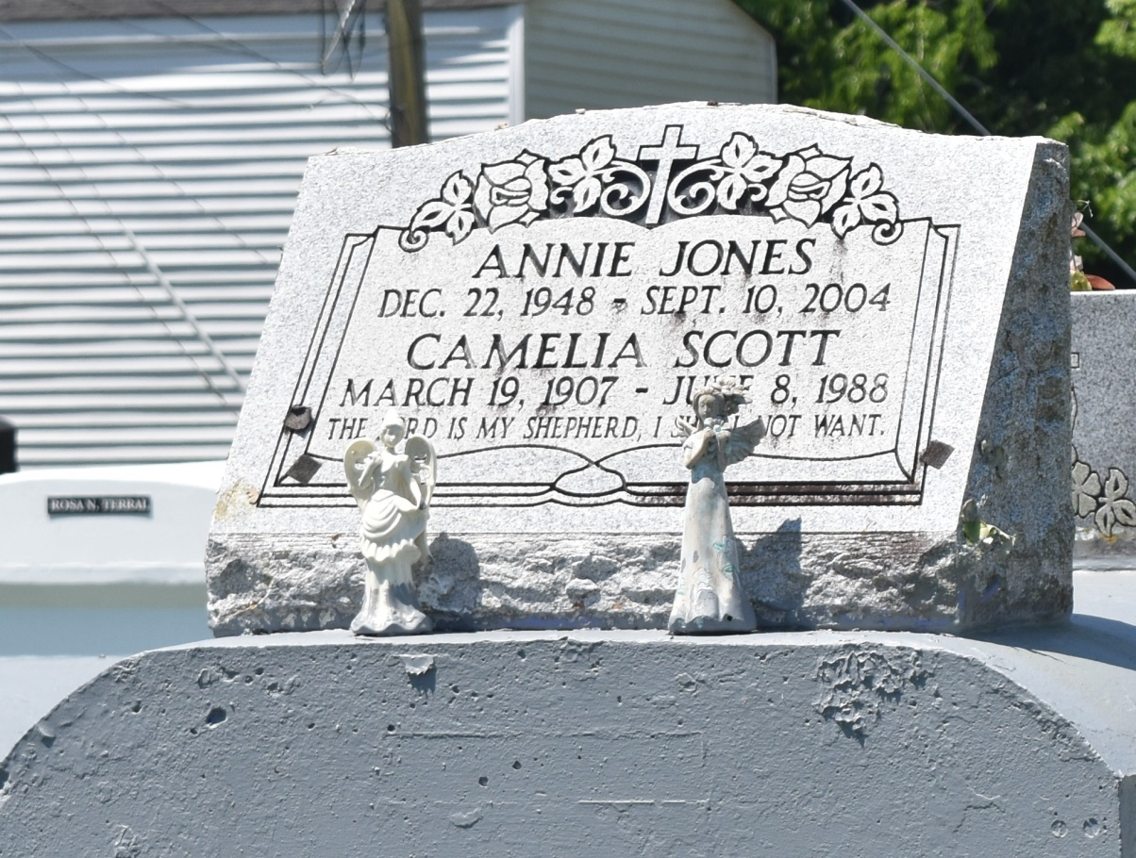

Annie Mae Jones, a cashier with Holmes Food Mart, died Sept. 10 of an aneurysm at West Jefferson Medical Center. She was 55. Mrs. Jones was born in LaPlace and lived in Reserve. She was a member of Greater New Plymouth Rock Baptist Church. Survivors include her husband, Cedell Jones; a son, Harris Wilson; two daughters, Taravia and Robin Jackson; two brothers, Wilbert Bright and Freddi Mitchell; and eight grandchildren. A funeral will be held Saturday at 11 a.m. at Greater New Plymouth Rock Baptist Church, 110 NW 13th St. in Reserve. Burial will be in Bethlehem Cemetery. Hobson Brown Funeral Home is in charge of the arrangements.

**Times-Picayune, The (New Orleans, LA) - Friday, September 17, 2004**

**Contributed by Jane Edson**