Ceola (Jordan) Jones-Tuckee

January 16, 1926 – January 7, 2007

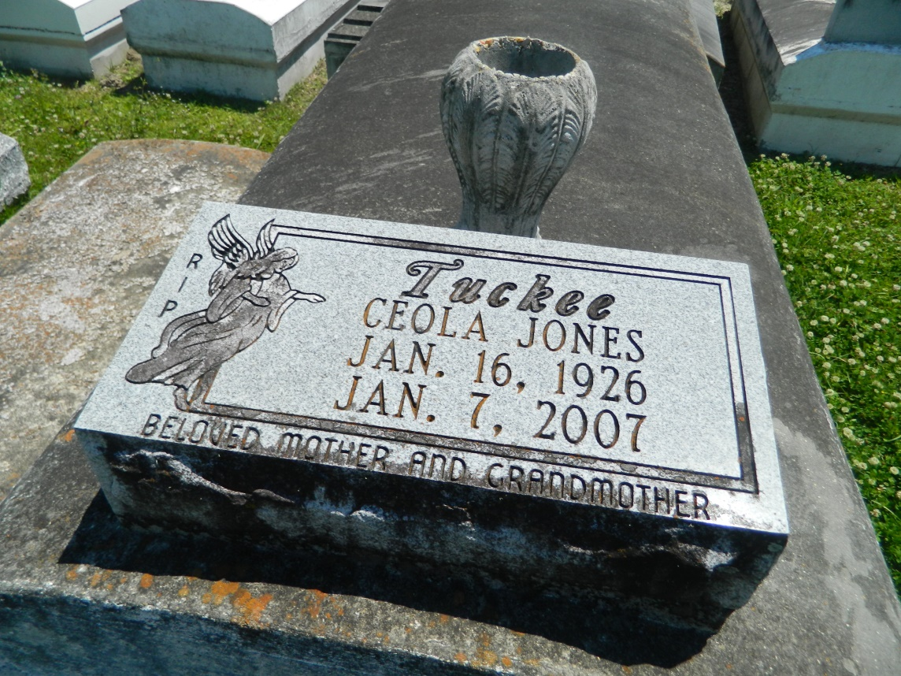

Ceola (Tuckee) Jones, of Reserve, LA at River Parishes Hospital, on Sunday, January 7, 2007 at 4:35 p.m. Age 80 years. Daughter of the late Mack Jordan and Mary Coleman. Reared by Selina and John Stewart. Wife by first marriage to the late Lloyd Picou and second marriage the late James Jones. Beloved mother of Gail Jones Hamilton of LaPlace, LA, Dianne Picou of Reserve, the late Leslie Jones and Lloyd Picou, Jr. Like a mother to Rev. Julius Ellis, LaPlace, LA. Grandmother of Melody, Harmony and Leslie Hamilton of LaPlace, LA and Bailee Picou of Reserve, La. Sister of Denise Joseph, Pauline Edwards, Florence Rayfield of Reserve, LA, Julia Irving of Hillaryville, LA, Clayton Jordan of LaPlace, LA, Rosetta Joshua of Marrero, LA and the late Helen Landix. Niece of Leon Leonard. Preceded in death by a devoted niece, Hilda Jasper. Also survived by a host of nieces, nephews, cousins and friends. A native and resident of Reserve, LA.

Relatives and friends of the family; also pastors, officers and members of New Pilgrim B.C., Milesville Memorial C.O.G.I.C., New Wine Christian Church, Beech Grove B.C. and neighboring churches are invited to attend the Funeral Services on Saturday, January 13, 2007 at 11:00 a.m. from the New Pilgrim B.C., 107 Pilgrim Dr., Reserve, LA. Rev. J. Bering, officaiting. Interment Bethlehem Cemetery, E 19th St., Reserve, LA. Visitation at the Church after 9:00 a.m. THE BALONEY FUNERAL HOME, L.L.C. 399 Earl Baloney Dr., Garyville, LA 70051 Information: (985) 5352450 in charge of arrangements

**Downloaded from legacy.com on 4/30/2018**