Roland Mason Sr.

August 26, 1936 – October 31, 2012

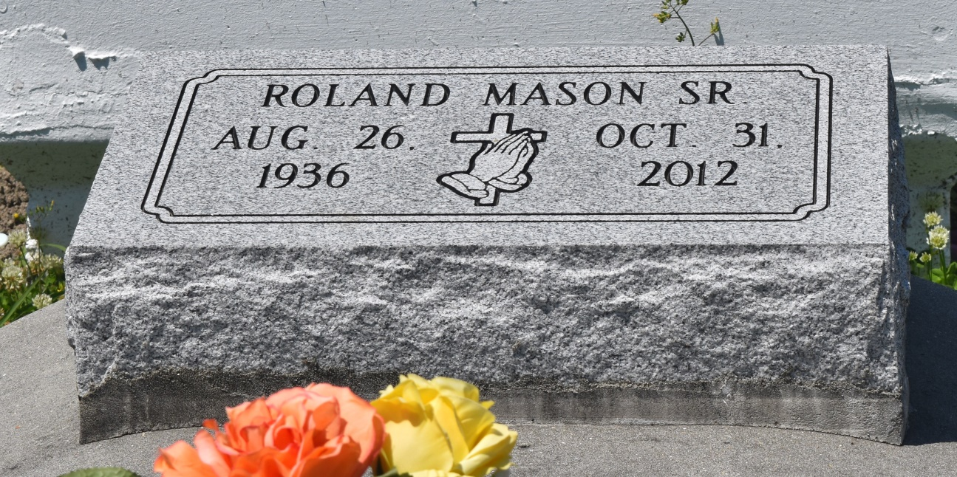

Roland Mason Sr. "Pop Noon" on Wednesday, October 31, 2012 at Twin Oaks Nursing Home, LaPlace, LA. Son of the late Mary Julia Burkley and Peter Mason, Sr. Husband of Louise Paul Mason. Father of Roland Mason, Jr., Ronald Mason, Roanna Fleming (Mark), Rosliand Walker (Jerry) and Karen Turley. Brother of Audrey Grover, Joean, Adam, Henry, Alexander, Raymond, Royal, Michael and Alvin Mason, the late Clarence, Louis and Peter, Jr. Mason  
  
Also survived by 10 grandchildren, 6 great grandchildren and a host of nieces, nephews, other relatives and friends. Age 76 years. A native of Reserve, LA and a resident of Norco, LA  
  
Relatives and friends of the family also pastors, officers and members of New Rescue Mission Baptist Church and all neighboring churches are invited to attend the funeral at New Rescue Mission Baptist Church, 361 East 14th Street, Reserve, LA on Wednesday, November 7, 2012 at 12 Noon Rev. Devin Mason, Pastor, Officiating. Interment Bethlehem Cemetery, Reserve, LA Visitation at the above named church from 11:00 AM until service time.  
  
SERVICED BY ROBOTTOM

**Times-Picayune, The (New Orleans, LA) - Sunday, November 4, 2012**

**Contributed by Jane Edson**