Ronald Mizell Sr.

January 1, 1945 – March 9, 2008

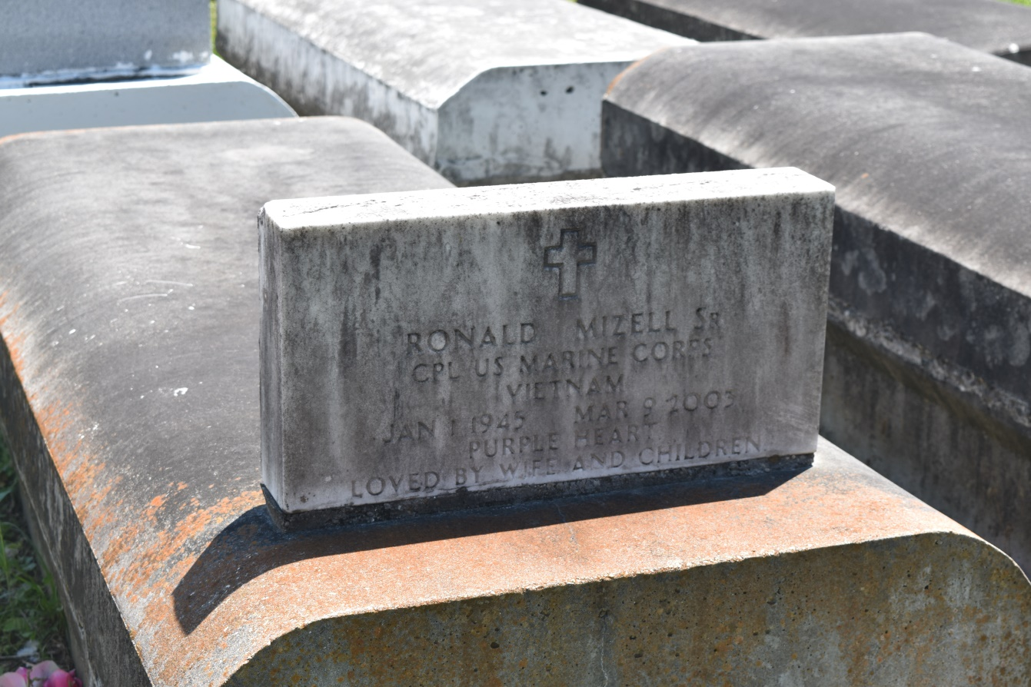

RESERVE - Ronald Mizell Sr., 58, a native of New Orleans and resident of Reserve, died March 16. He was the husband of Audrey Delia Mizell and father of Klona Bowers, Trina Morrow, Beatrice, Sanya, Ronald Jr. and Kentroy Mizell, and stepfather of Anthony and Gregory Lennix.  
  
He was also the brother of Myrtle Nicholson, Fannie and Harrison Mizell.  
  
He is also survived by seven grandchildren.  
  
He was a U.S. Marine Corps veteran, recipient of the Purple Heart and a retired steelworker.  
  
Services were March 18 at Pilgrim Baptist Church, Reserve, with interment at Bethlehem Baptist Cemetery, Reserve.

**L'Observateur (La Place, LA) - Tuesday, March 25, 2003**

**Contributed by Jane Edson**