Warren Nicholson

June 21, 1946 – September 19, 1999

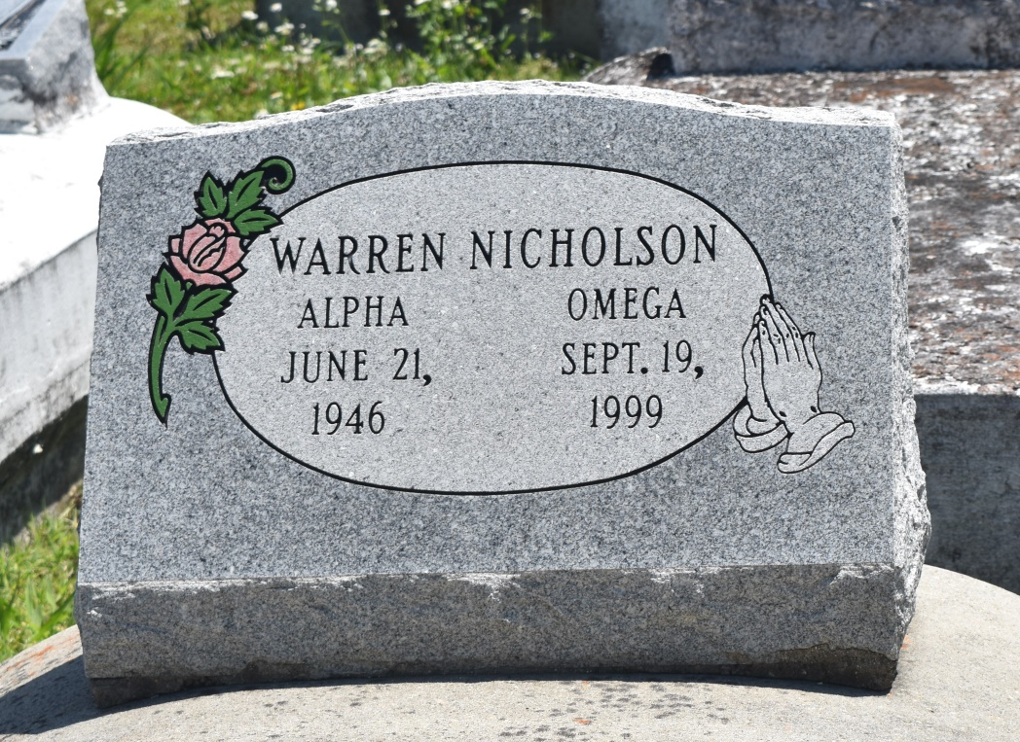

LAPLACE Warren Nicholson, 53, a native and resident of Reserve, died Sept. 19. He was the son of Lucy Alexander Nicholson and the late Austin Nicholson and the brother of Augustine Dorris and Ethelene, Lillian Marie, Rodney and Ervin Nicholson.  
  
Services were Saturday at 11 a.m. at New Vision Missionary Baptist Church, LaPlace, with interment at Bethlehem Cemetery, Reserve. Visitation starts at 10 a.m.

L'Observateur (La Place, LA) - Monday, September 27, 1999

Contributed by Jane Edson