Wilson Elliot Placide Sr.

May 5, 1937 – January 16, 2015

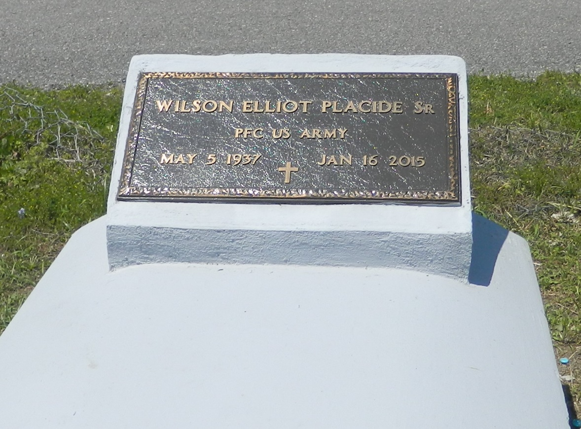

Wilson E. "Sink" Placide Sr. at the age of 77 years departed this earthly life and entered into eternal rest on Friday, January 16, 2015 at Ochsner Health System of Kenner, La. Son of the late Marie and Budwin Placide Sr. Loving father of Sheryl Davis, Gloria Keller, Karen (John) Landry, Wilson (Elvira) Placide Jr., Rachel P. (Reginald) VanNorman, Terrance (Nona) Placide, Perry (Melissa) Placide, Randall (Kelli) Joseph-Placide, Rodney (Christine) Joseph-Placide, Renel Joseph, Tanya Joseph, Kendell and Daryl Taylor. Brother of Carol Lennix and Paul Placide. Preceded in death by siblings Budwin Jr., Edward, and James Placide, Dianne P. Alexander and grandson Antoine Evans. Also survived by 41 grandchildren, a host of great-grandchildren, nieces, nephews other relatives and friends. A devoted friend of Harry Sanders Jr., Rosalind Sanders and Freddie Young.  
  
Priest and parishioners of Our Lady of Grace Catholic Church of Reserve, La., Employees of St. John Sheriff Office and all neighboring churches are invited to attend the mass of Christian burial on Saturday January 24, 2015 at 10:00am at Our Lady of Grace Catholic Church 772 Hwy 44 Reserve, La. Reverend Christopher C. Amad:SSJ celebrant. Interment in Bethlehem Cemetery of Reserve, La. Visitation will be at the above name church from 8:00 until the Rosary at 9:15am.  
  
Bardell's Mortuary of Mt. Airy, La. in charge. Information: 985-535-6837.

**Times-Picayune, The (New Orleans, LA) - Friday, January 23, 2015**

**Contributed by Jane Edson**