Agnes (Carter) Preston

Abt. 1916 - July 30, 2001

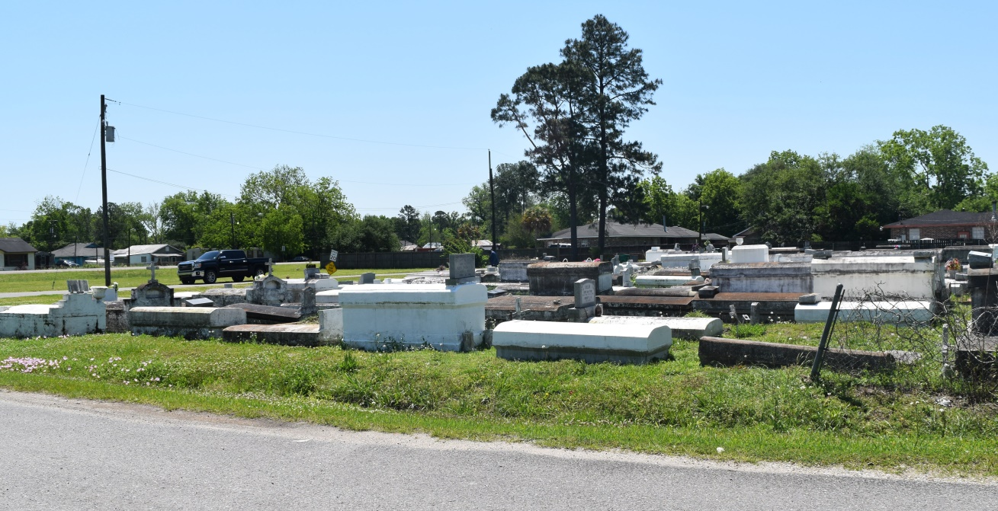

PRESTON

RESERVE - Agnes Carter Preston, 85, a resident of Reserve, died July 30.

She was the wife of the late John Preston and mother of Eva Joseph, Audrey

LeBray and Ernest, Norman, John and the late Diane Johnson. She was the daughter of the late James C. and Mary C. Kelly and sister of Clarence Carter. She is survived by 19 grandchildren, 38 great-grandchildren and seven great-great-grandchildren.

Services were Aug. 6 at Bethlehem Baptist Church, Reserve, with interment at the church cemetery.

**L'Observateur, LaPlace, LA; August 08, 2001**