Henry Sanders Sr.

February 28, 1923 – August 9, 2007

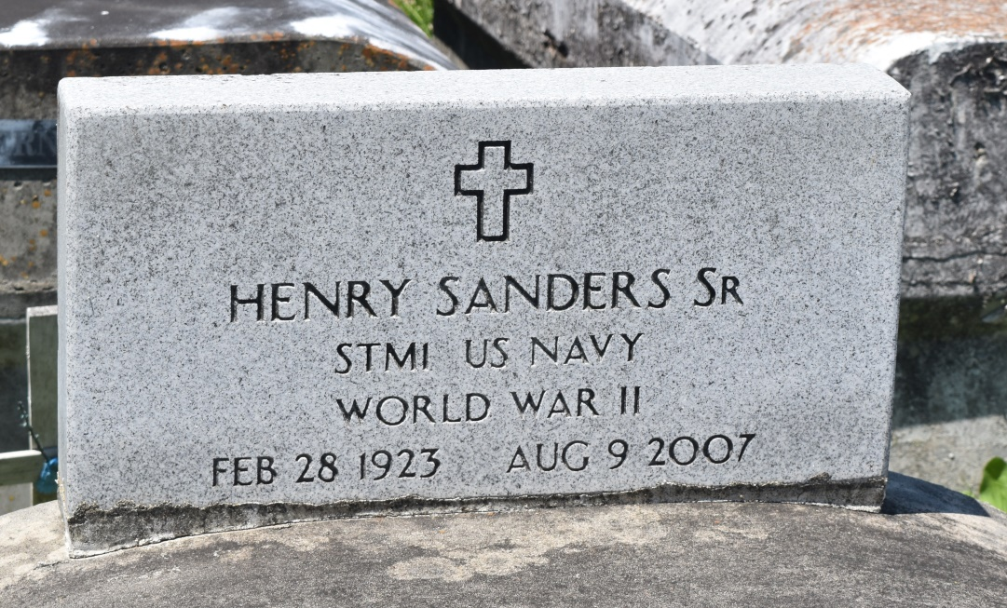

Henry Sanders on Thursday, August 9, 2007 at St. James Parish Hospital, Lutcher, LA. Son of the late Ursin and Eugenia Toney Sanders. Husband of Emma Frank Sanders. Father of Earl Sanders, Madelyn Sanders Tyler, Henry Sanders Jr., Geneiva Sanders Jones, Allen Sanders Sr., Gerald Sanders, Jackie Sanders Hargrove, Lionel Sanders, Leonard Sanders Sr., Debbie Sanders Craighead; Paula Brown, Magary Brown, Ingrid Brown, Thomas (Bill) Brown, Henry Ann Brown, and Gerald Brown. Brother of Mabel McGee of Los Angeles, CA, the late Harry, Hayward, and Frances Sanders. Also survived by 31 grandchildren, 15 great grandchildren, and a host of nieces, nephews, other relatives and friends. Age 84 years. A native and resident of Reserve, LA.  
  
Relatives and friends of the family; also pastors, officers, and members of Bethlehem Missionary Baptist Church and all neighboring churches are invited to attend the Funeral Service at Bethlehem Missionary Baptist Church, 146 East 20th Street, Reserve, LA on Wednesday, August 15, 2007 at 12:00 noon. Rev. Forell Bering, Sr., Pastor, Officiating. Interment Bethlehem Missionary Baptist Church Cemetery, Reserve, LA. Visitation at the above named church from 10:00am until service time.  
  
SERVICED BY ROBOTTOM

**Times-Picayune, The (New Orleans, LA) - Tuesday, August 14, 2007**

**Contributed by Jane Edson**