Norman Weston

April 4, 1927 – February 1, 2015

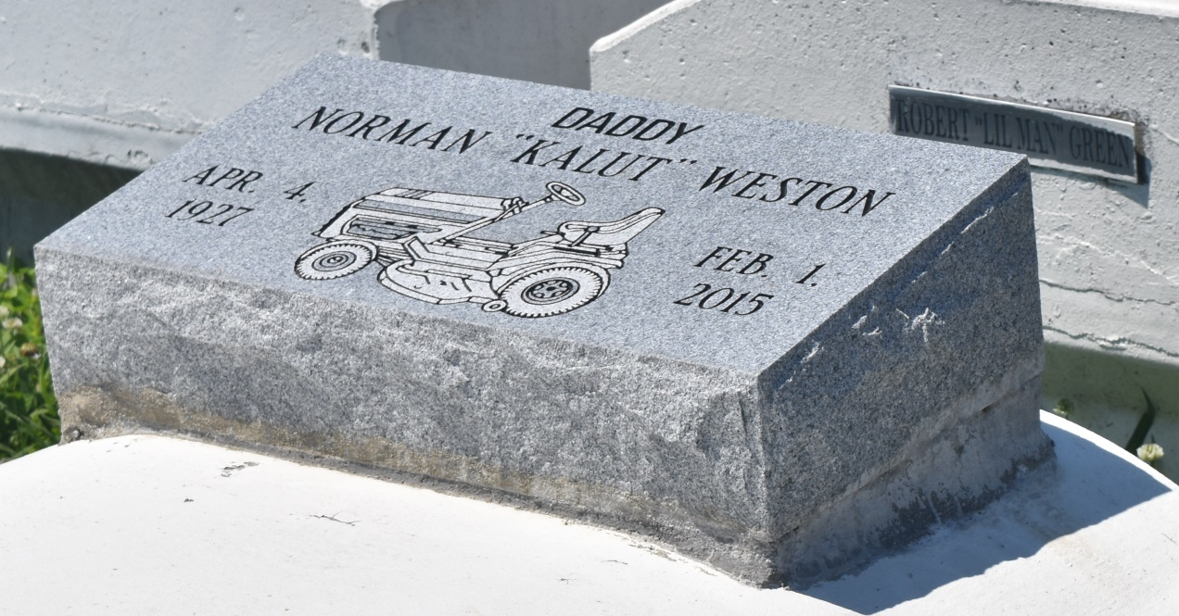

NORMAN L. WESTON "KALUT" on Sunday, February 1, 2015 at his home in Reserve, LA. Son of the late Cornelius Cook and Adam Weston. Husband of the late Caroline Johnson Weston. Father of Norma Jean Dukes (Tom), Terry Weston (Sandra) and Ann Fenroy (Melvin, Sr.). Brother of the late Sedonia Johnson, Beatrice Richardson, Lester, Sr. Lorenza and Joseph Weston. Also survived by 8 grandchildren, 18 great grandchildren, 1 great great grandchild and a host of nieces, nephews, cousins, other relatives and friends. Age 87 years. A native and resident of Reserve, LA.  
  
Relatives and friends of the family, also pastors, officers and members of Bethlehem Baptist Church and all neighboring churches are invited to attend the Funeral Service at Bethlehem Baptist Church, 147 E. 20th Street, Reserve, LA on Friday, February 6, 2015 at 11:00 AM. Rev. Forell Bering, Pastor, Officiating. Interment Bethlehem Cemetery, Reserve, LA. Visitation at the above named church from 9:00 AM until Service.  
  
SERVICED BY ROBOTTOM

**Times-Picayune, The (New Orleans, LA) - Wednesday, February 4, 2015**

**Contributed by Jane Edson**