Arthur Anderson

September 30, 1930 – November 19, 2002

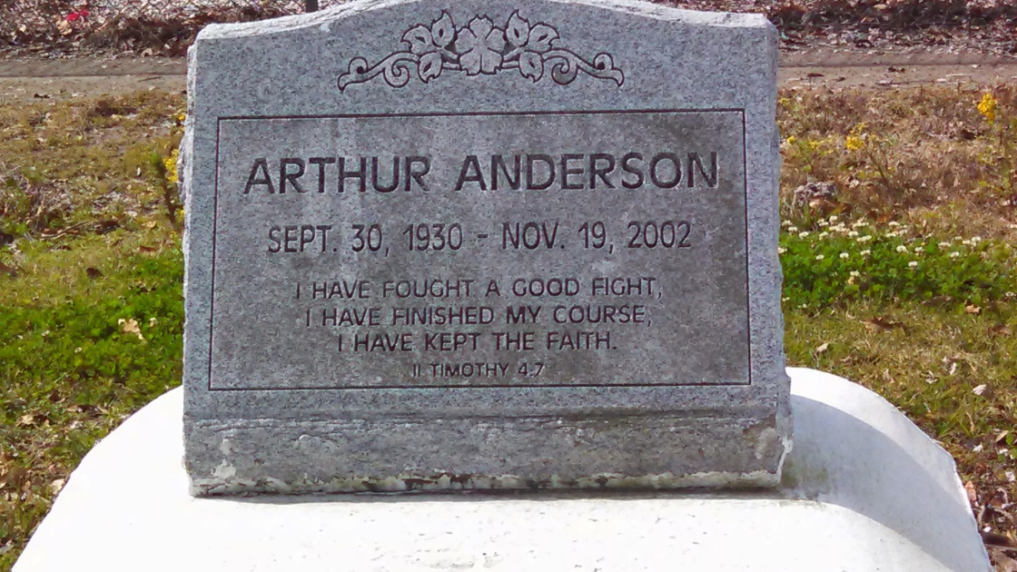

Photo by GeniHound

Arthur Anderson a retired forklift operator for Godchaux Henderson Sugar Refinery departed this life on Thursday, November 19, 2002 at 2:50 pm in New Orleans, LA. Husband of Claudia L. Anderson. Son of the late John and Elizabeth Anderson. Father of Jimmy, Brenda, and Lesa Anderson, Melvin Picou, Glenda Clark, Margie Robertson, Joyce Riley, Barbara Johnson, and Lori Joseph. Brother of Leona Wishom, Gladys Anderson, and Louella Anderson. Father in law of Terri Anderson, Donner Picou, Earl Clark Jr., Clayton Robertson, Charles Riley Sr., Calvin Lumar, Carl Johnson Sr., Solomon Joseph and Michael Williams. Brother in law of Johnny Wishom Sr. Also survived by 21 Grandchildren, 3 Great-grandchildren and a host of nieces, nephews, other relatives and friends. A devoted friend of Rev. Clarence Crayton. A native of Garyville, LA and a resident of Reserve, LA for 50 years. Age 72. Relatives and friends of the family, pastor officers, and members of the New Pilgrim Baptist Church, Beech Grove B.C., New Zion Full Gospel B.C., Mt. Zion #1, and all neighboring churches, employees of Mercy Hospital, East Jefferson Hospital, N.N.A. of St. Charles, Frank's Supervalue, Doctor's Hospital, River Parishes Hospital, Kenner Regional Medical Center, East St. John High and Elementary School, Leon Godchaux Junior High, Hertz Rental Car, Delta Beverage, former employees of Godchaux Henderson Sugar Refinery, St. John the Baptist Parish Sheriff Department and Clerk of Court Office are invited to attend the funeral service on Saturday, November 23, 2002 at 12:00 Noon from the New Pilgrim B.C., 107 Pilgrim Dr., Reserve, LA. Rev. Forell Bering Pastor officiating. Interment in Marathon Bishop Cemetery, Garyville, LA. Visitation at the funeral on Friday nite from 5-7 and on Saturday from 10-until funeral time. Services Entrusted to Hobson Brown Funeral Home.

Times-Picayune, The (New Orleans, LA) - Friday, November 22, 2002

Contributed by Jane Edson