Pamela Marie (Carr) Evans

February 14, 1952 – August 13, 2013

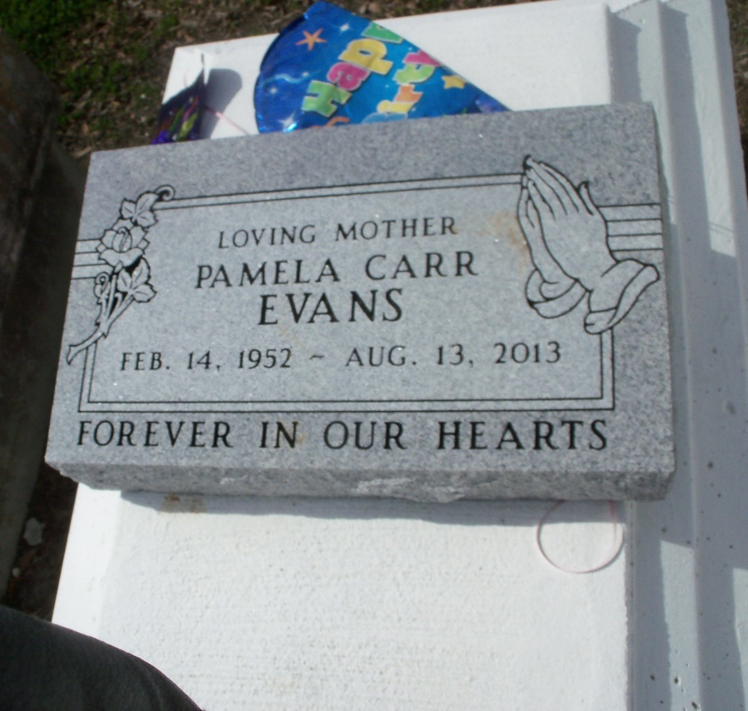

Photo by GeniHound

Pamela Marie Carr-Evans at the age of 61 yrs departed this earthly life and entered into eternal rest on Tuesday, August 13, 2013, at University Hospital of New Orleans, LA. Beloved daughter of the late Edna LaBranch Carr and Leroy Carr, Sr. Loving mother of Rodney Evans, Jr. (Courtney), and Elza Lee Evans IV. Sister of Norman Carr of LaPlace, LA, Dianne Cambre, and Shirley Mae Lewis of San Diego, CA. and the late Leroy Carr, Jr. Grandmother of Rodney Evans III. Beloved ex-wife of Rodney Evans Sr. Sister-in-law of Jo Ann M. Alexander and Raydel Morris Sr. Also survived by a host of nieces, nephews, and other relatives and friends. A native of Garyville, LA and a resident of LaPlace, LA. Pastors, officers, and members of The New Rescue Mission Baptist Church and all neighboring churches are invited to attend the funeral services on Wednesday, August 21, 2013, at 11:00a.m. at The New Rescue Mission Baptist Church at 361 East 14th St. Reserve, LA. Pastor Devin K. Mason Sr. officiating. Visitation will be at the above named church from 9:00 a.m. until service time. Interment in Bishop Cemetery of Garyville, LA. Bardell's Mortuary of Mt. Airy, LA in Charge. Information: 985- 535-6837.

Times-Picayune, The (New Orleans, LA) - Sunday, August 18, 2013

Contributed by Jane Edson