James Jackson

September 9, 1953 – January 4, 2003

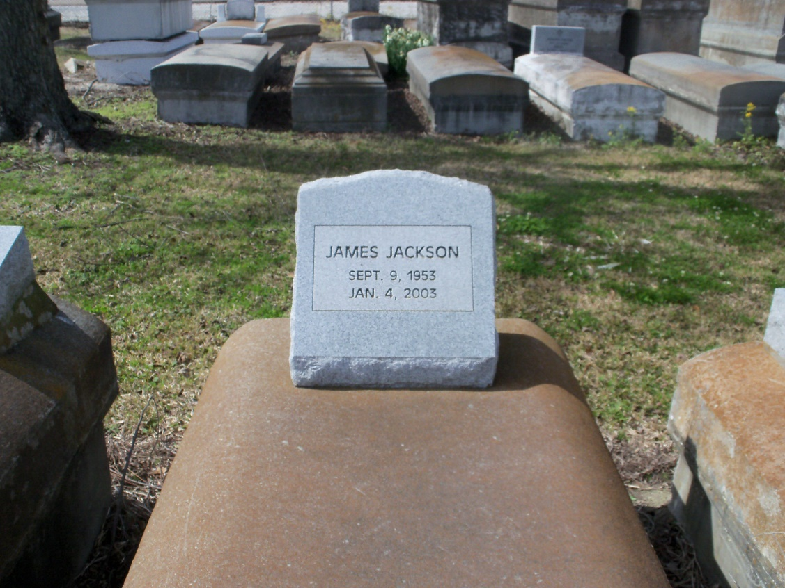

Photo by GeniHound

Mount Airy man dies in car crash A traffic crash in Garyville on Saturday killed a Mount Airy man and injured four people, State Police said. James Jackson, 49, died at the scene about 5:45 p.m. after turning in front of an oncoming car, police said. Jackson was driving north on U.S. 61 when he tried to turn left onto Louisiana 54, according to Lt. William Dorris and Sgt. Catherine Flinchum with the State Police. Jackson's 1997 Chrysler Cirrus was struck by a southbound 1996 Ford Thunderbird driven by Jared Boudreaux, 21, of Westwego. Boudreaux and his passengers -- Reba Desota, 18, of Gramercy, and Robert Stout, 23, and Joshua Pierce, 13, both of Marrero -- were being treated at River Parishes Hospital in LaPlace.

Times-Picayune, The (New Orleans, LA) — Sunday, January 5, 2003

\*\*\*\*\*

GARYVILLE - James Jackson, 49, a native of Garyville and resident of Mt. Airy for 21 years, died Jan. 4. He was the husband of Betty Jean Jackson and father of Katrina Davis and Constance Cook. He was the son of Lawrence Jackson Sr. and the late Ernestine Jackson and brother of Mercedes Stewart, Alice Gardner, Olivia Dickerson and Edward, Robert, Harold, Nelson, Nathan and Lawrence Jackson Jr. He was the grandson of Pamela Vincent. He is also survived by one grandchild. Services were Jan. 10 in the chapel of Hobson-Brown Funeral Home, Garyville, with interment at Marathon Bishop Cemetery, Garyville.

L'Observateur (La Place, LA) — Wednesday, January 15, 2003

Both contributed by Jane Edson