Edna Scott

Abt. 1927 – September 3, 2019

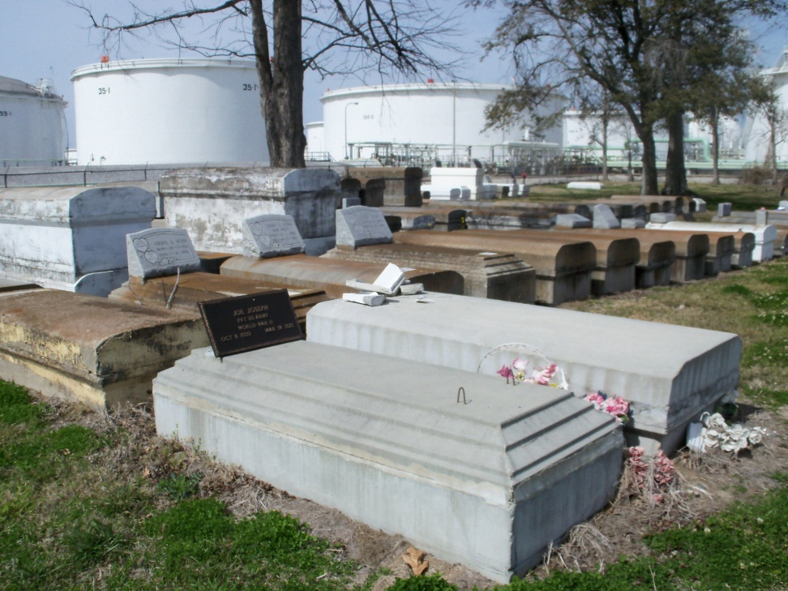

Photo by GeniHound

Edna Scott at the age of 92 transitioned on September 3, 2019. She is survived by a host of family and friends. Celebration will be held on Saturday September 14, 2019 at Lifehouse Church, 3556 W. Airline Hwy, Reserve, La, at 10:00am. Laurie Adams, Officiating, Viewing at the church from 9:00 am until service time. Interment in Marathon Bishop Cemetery Garyville, LA. Service Entrusted to Hobson Brown Funeral Home, 134 Daisy Street, P.O. Box 61, Garyville, LA 70051.

Published in The Times-Picayune (New Orleans, LA) from Sep. 12 to Sep. 14, 2019.