Joseph Smith

November 28, 1927 – May 6, 2003

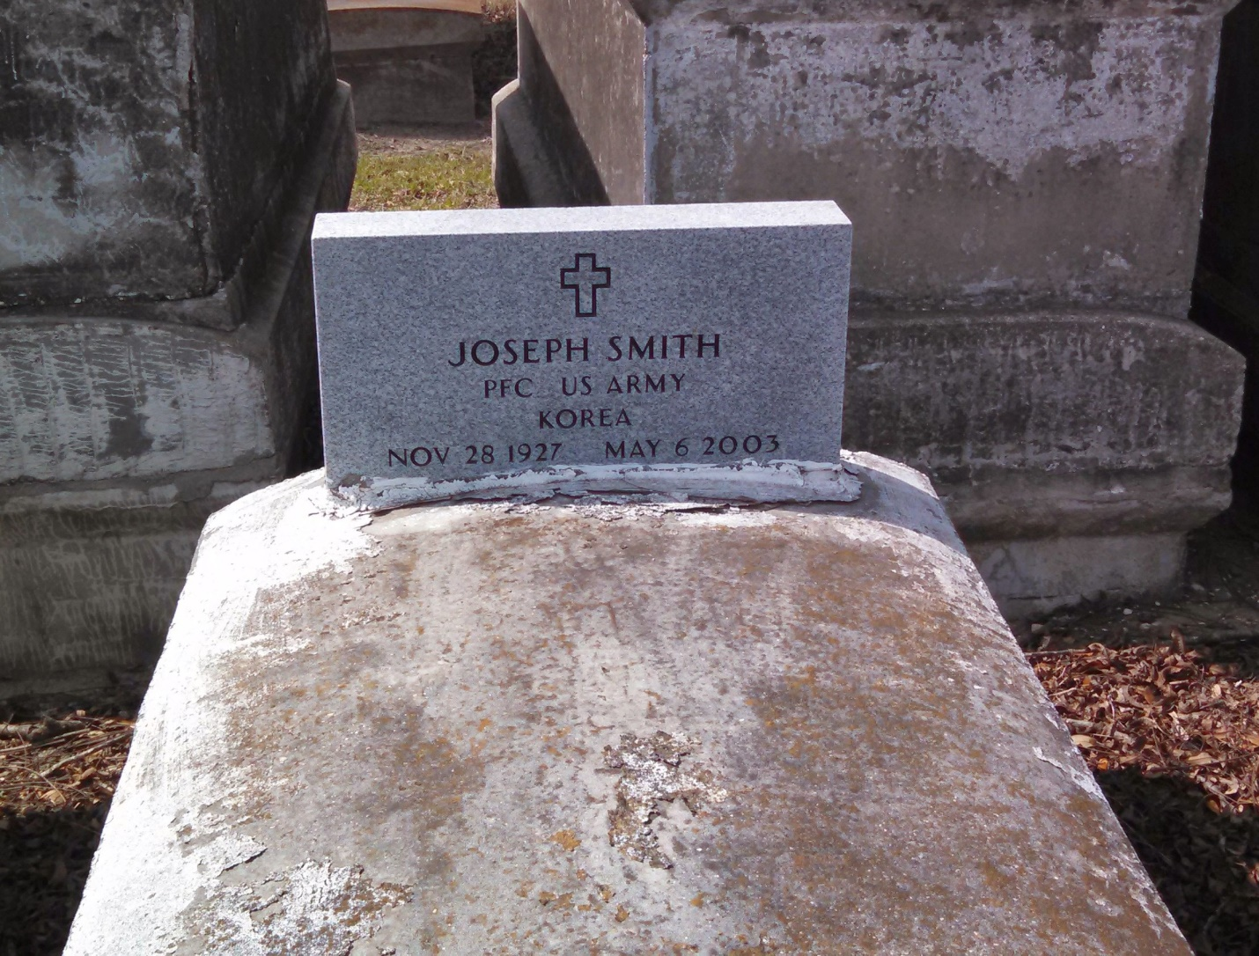

Photo by GeniHound

Joseph "Joe Joe" Smith, a retired laborer, died May 6 of esophageal cancer at River Parishes Hospital. He was 75. Mr. Smith was a lifelong resident of Reserve. Survivors include his wife, Aldonia Smith; five daughters, Lorenza Carter, Betty Melancon, Wanda Young, Yvette Thomas and Vanessa Greenup; a sister, Janice Frazier; 16 grandchildren; and 16 great-grandchildren. A funeral will be held Saturday at 9 a.m. at St. Joe Missionary Baptist Church in Lutcher. Visitation will begin at 8 a.m. Burial will be in Marathon Bishop Cemetery in Garyville. The Baloney Funeral Home is in charge of arrangements.

Times-Picayune, The (New Orleans, LA) ; Friday, May 9, 2003

Contributed by Jane Edson