Augustine (Bolden) Tuco

August 28, 1944 – June 26, 2007

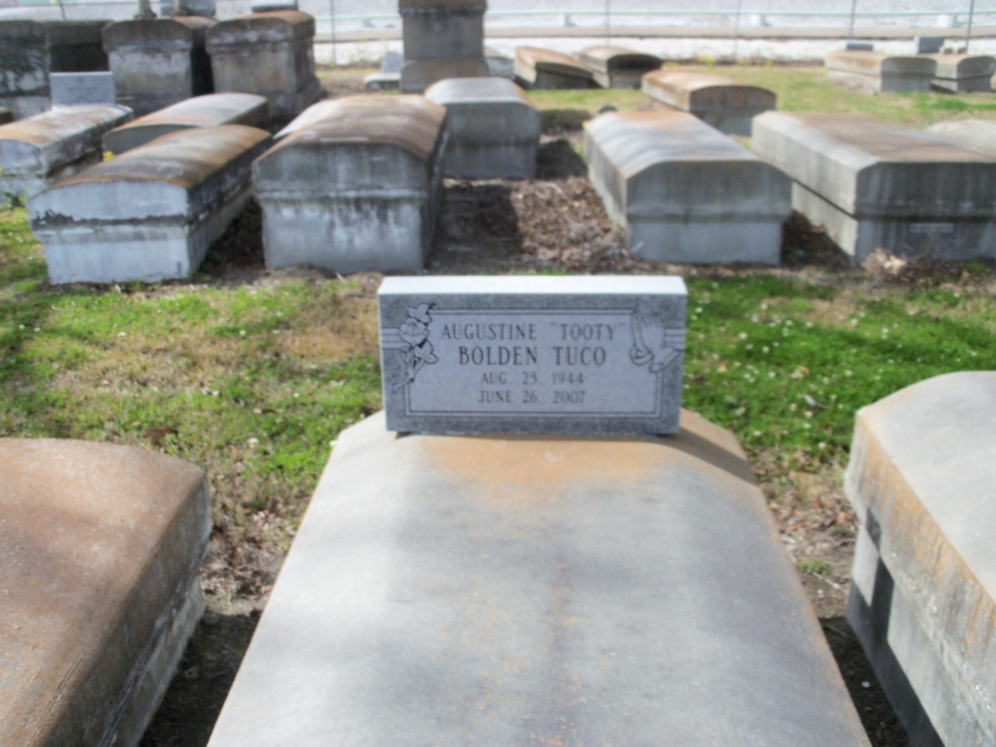

Photo by GeniHound

Augustine "Tooty" Bolden Tuco, age 63, a homemaker, departed this life on Tuesday, June 26, 2007 in LaPlace, La. Daughter of the late Emile and Ethel (Driver) Bolden; Wife of the late Oscar "Lewis" Tuco, Sr.; Mother of Edwina, Irene, Lorene, Orita, Peggy, Sandra, Aurelia, Bernadine, Oscar, Jr., August, Elroy, and the late Antoine Tuco. Sister of Georgina Brown, Emelda Walker, Emile Jr., August and Charles Bolden; also survived by 24 grandchildren, 6 great-grandchildren, and a host of nieces, nephew, cousins, and friends. A native of Garyville and a resident of LaPlace, La. Pastor, Officers and members of New Rescue Mission Missionary B.C. and all Neighboring Churches are invited to attend the Funeral Service on Saturday, June 30, 2007 at 11:00a.m. at the above name church, 361 E. 14 St., Reserve, La., Rev. Dr. Joseph Smith, Sr., Officiating. Interment in Marathon Bishop Cemetery, Garyville La. Visitation on Saturday at the church from 10:00 a.m. until service time. Service Entrusted to Hobson Brown Funeral Home, Garyville, La 985-535-2516

Times-Picayune, The (New Orleans, LA) - Friday, June 29, 2007

Contributed by Jane Edson