George Washington

December 15, 1918 – June 3, 2003

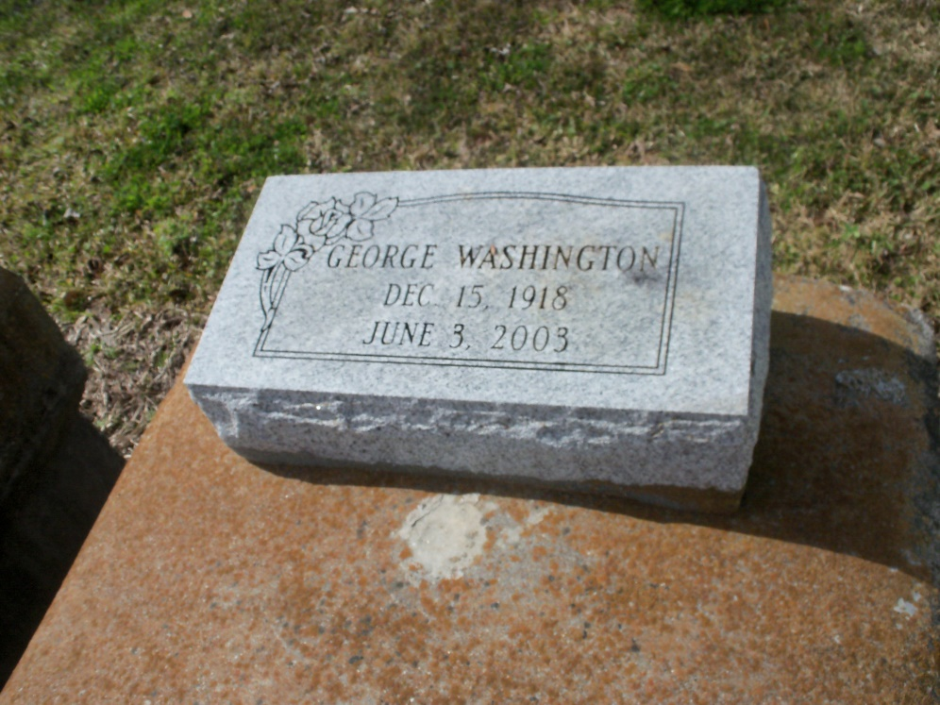

Photo by GeniHound

George Washington of Garyville, La. on Thursday, June 5, 2003 at Kenner Regional Medical Center. Husband of Gustavia Anderson Washington. Son of the late Septine and Augustine Washington. Father of Georgia Mae Carey of New Orleans, Doris Cambre and Gerald Washington of Garyville, Marcelle Nelson and Geraldine Dickson of LaPlace, Elaine Victor of Reserve, LA and Lester Washington of San Antonio, Tex. Brother of James Washington of Houston, Tex. Preceded in death by (3) sisters, (1) brother (1) granddaughter (2) nieces. Fatherin-law of Alice Washington, Calvin Carey, James Cambre, Terry Victor and Frank Dickson. Brother-in-law of Delores Washington. Also survived by (13) grandchildren, (34) great grandchildren, (1) great great-granddaughter, a host of nieces, nephews, cousins and friend. A native and resident of Garyville, La. Age 84 years. Relatives and friends of the family, also priest and parishioners of St. Hubert Catholic Church, pastor, officers and members of Bethlehem B.C., Mt. Zion #1 B.C., Mt. Zion #2 B.C., Providence B.C., Pilgrim B.C. and neighboring churches, employees of Burn's Security and St. Charles Parish Censortium are invited to attend a Mass of Christian Burial on Tuesday, June 10, 2003 at 11:00 AM from the St. Hubert Catholic Church, Garyville, La. Father Caluda, celebrant. Interment Marathon Bishop Cemetery, Garyville, La. Visitation at the church after 8:00 AM. The Baloney Funeral Home in charge of arrangements.

Times-Picayune, The (New Orleans, LA) — Monday, June 9, 2003

Contributed by Jane Edson