Charles Baker

September 15, 1947 – February 26, 2005

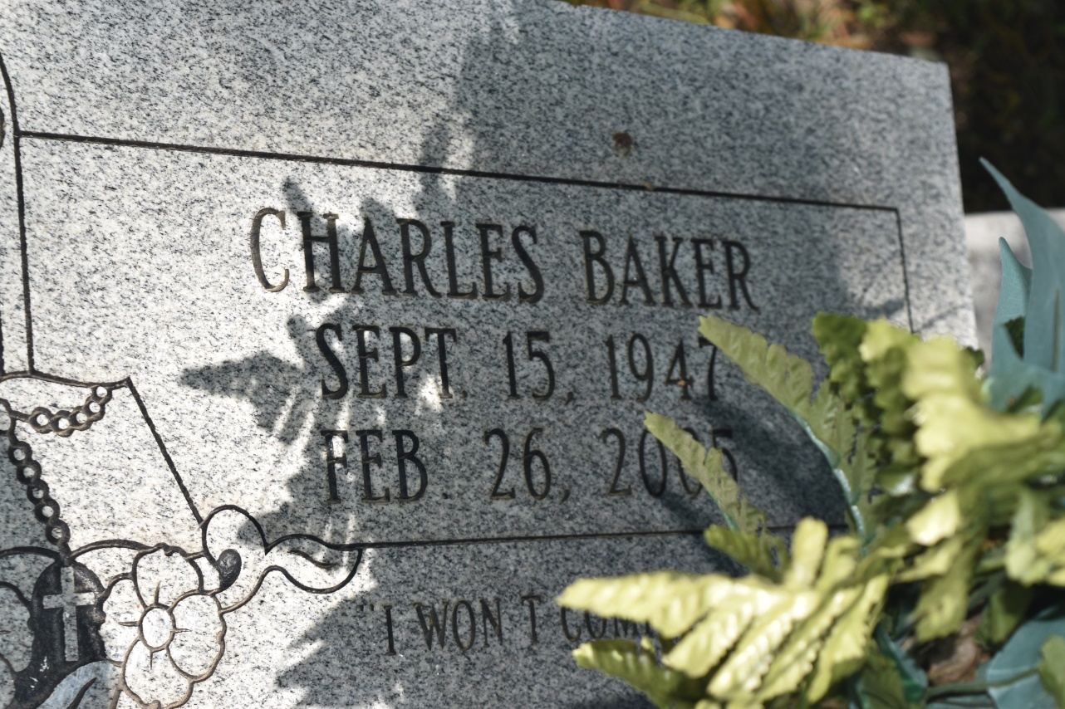

Charles C.J. "Pop" Baker, a retired laborer, died Saturday of cancer at Canon Hospice. He was 57. Mr. Baker was born in St. John the Baptist Parish and lived in New Orleans for the past year. He was a member of St. Mark Baptist Church in Gretna. Survivors include his wife, Nora Baker; three sons, Glenn, Charles and Dwayne Jackson; a stepson, Jermaine Davis; three stepdaughters, Crystal and Kim Davis and Nicole Williams; three brothers, Ollie, Gary and Jerry Baker; and four sisters, Toni Baker, Mable Pierre, Carolyn Young and Mae Lockett. A funeral will be held Saturday at 10 a.m. at St. Mark Baptist Church, 1929 Huey P. Long Ave., Gretna. Visitation will begin at 8 a.m. Burial will be in Jerusalem Cemetery in Edgard. Murray Henderson Funeral Home is in charge of the arrangements.

Times-Picayune, The (New Orleans, LA) - Friday, March 4, 2005

Contributed by Jane Edson