Delbert Micheal Bethancourt

August 21, 1961 – November 12, 2022

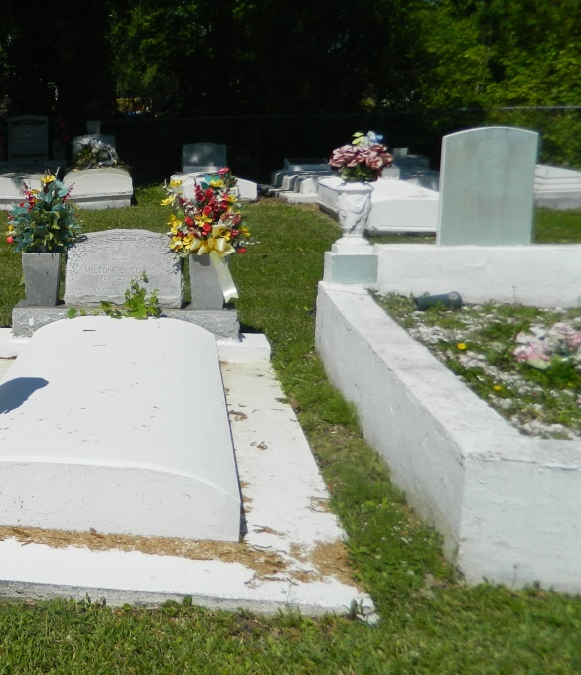

On Saturday, November 12, 2022, at his residence in Edgard, LA, God looked down on Earth and called our beloved brother home at the age of 61. Delbert Micheal (Duke) Bethancourt was born on August 21, 1961, to the late Felmon Bethancourt and Gloria Rainey Bethancourt. He was baptized at Greater Woodville Baptist Church. Educated in the St. John the Baptist school system, Delbert graduated from West St. John High in 1980.  
 Delbert leaves to cherish his memories with his loving daughter, Kanesha Gordon; grandson, Kae'Jean Kinderick; mother, Gloria Rainey Bethancourt; four sisters, Shawna and Andrea Bethancourt, Deidre Gauthier, and Chandra (Darrell) Landry Sr.; nieces, Odyssey (Casey) Welch, Dashanta Bethancourt, Ambrey Favorite, and Kierston Gauthier; nephews, Cameron (Lashonka) Bethancourt, Aaron Bethancourt, Blaine Gauthier, and Darrell Landry Jr.; three great-nieces; five great-nephews; aunts, Patricia Montgomery, Rosalie Allen, and Brenda Burke; uncles, Lance Rainey Sr. and Arthur Rainey; devoted friends, Merlin Prudeaux and Terry (Chippie) Johnson Jr.; and a host of other relatives and friends.  
 He was preceded in death by his father, Felmon Bethancourt; brother, Christopher Bethancourt; grandparents, Floristal Bethancourt, Evelyn Hall Bethancourt, Silas Rainey Sr., and Somoria W. Rainey; uncles, Daniel Sr., Norman Sr., Therold, and Dennis Bethancourt, and Silas Sr., Paul, Wallace, and Lester Rainey; aunts, Catherine R. Johnson, Dianne Vinnette, Estelle B. Irving, and Juanita B. Williams.  
"Thank you Duke for always looking after us; until we meet again, we love you."

~ your loving sisters

A celebration of life honoring Delbert "Duke" Bethancourt will be held on Saturday, November 26, 2022, at New Jerusalem Baptist Church, 152 E. 6th St., Edgard, LA 70049. Visitation from 9am-11am. Service will begin at 11am. Interment to follow at New Jerusalem Baptist Church Cemetery. Final care and professional services entrusted to Treasures of Life Funeral Services, 315 E. Airline Hwy., Gramercy, LA 70052.

**Treasures of Life Funeral Services, Gramercy**