Caroline (Gale) Borne

June 16, 1926 – November 5, 2008

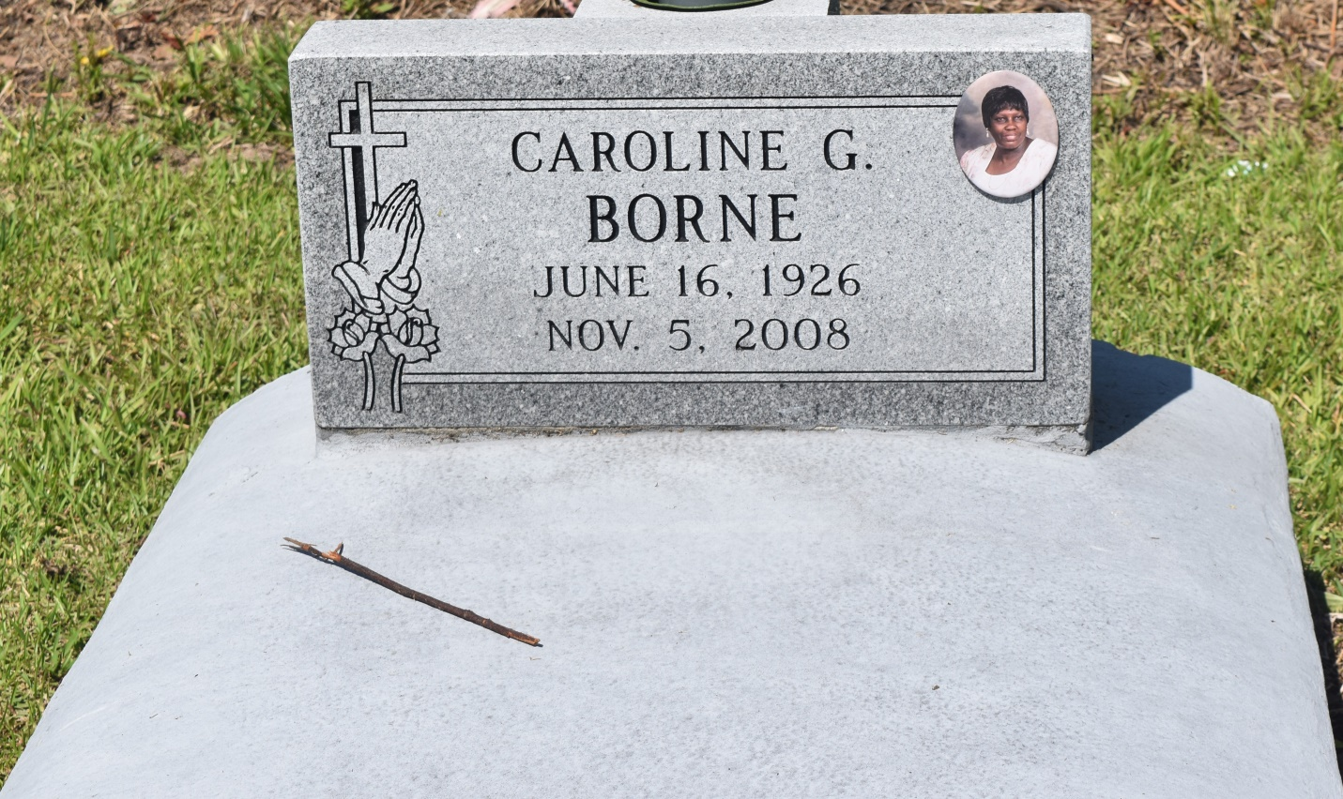

Caroline Borne, 82, died November 5, 2008. She was wife of Joseph Borne, mother of Theresa Gale-Sanders and Mary Ann Davis, grandmother of Rayfield Davis, Reonda Davis, Michael Sanders Jr. and Maya Sanders, great-grandmother of Rene'Shea Davis and sister of Angie Cannon.  
  
She was preceded in death by son Adrian Davis, parents William Gale and Pearl Gale, brother Matthew Gale Sr. and sister Victoria Stone. She was a native and lifelong resident of Edgard.  
  
Relatives, friends, employees of T Lanaux & Sons, CSBC Law Firm and CRC Warehousing and Transportation and all surrounding churches are invited to attend a funeral service at New Jerusalem B.C., 152 E. 6th St., Edgard, La., on Saturday, November 15, at 11 a.m. Rev. Joseph Johnson officiating. Church visitation from 9 a.m. until service. Burial at church cemetery.

L'Observateur (La Place, LA) - Friday, November 14, 2008

Contributed by Jane Edson