Christopher Borne, Sr.

December 25, 1929 – September 10, 2000

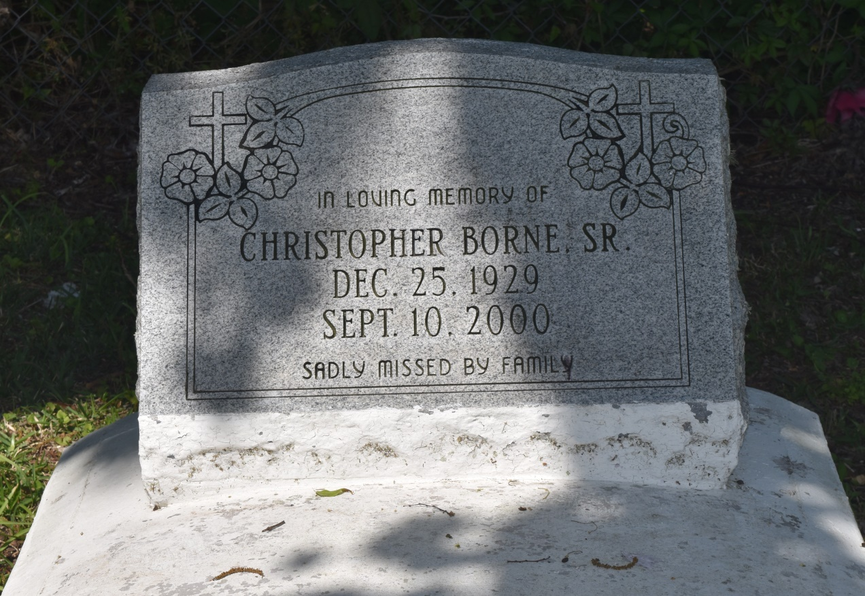

Christopher Borne Sr., a retired construction worker, died Sept. 10 of complications from a stroke at St. James Parish Hospital in Lutcher. He was 70. Mr. Borne was a native of Edgard and a resident of Vacherie.

Survivors include his wife, Carrie Lee Jasmin Borne; four daughters, Yvette and Jill Borne, LeJeanne Luke and Valecia Colton; three sons, Maldon, Christopher Jr., and Reginald Borne; two sisters, Ophelia Baloney and Eloise Briscoe; three brothers, Jonathan Ralph, Norman Borne and Romalis Jasmin; and six grandchildren.

A funeral will be held Saturday at 11 a.m. at New Jerusalem Baptist Church in Edgard. Visitation will begin at 9 a.m. Burial will be in the church's cemetery. Earl Baloney and Sons Mortuary is in charge of the arrangements.

Times-Picayune, The (New Orleans, LA) - Friday, September 15, 2000

Contributed by Jane Edson