Della M. (Louper) Borne

May 14, 1943 – June 30, 2001

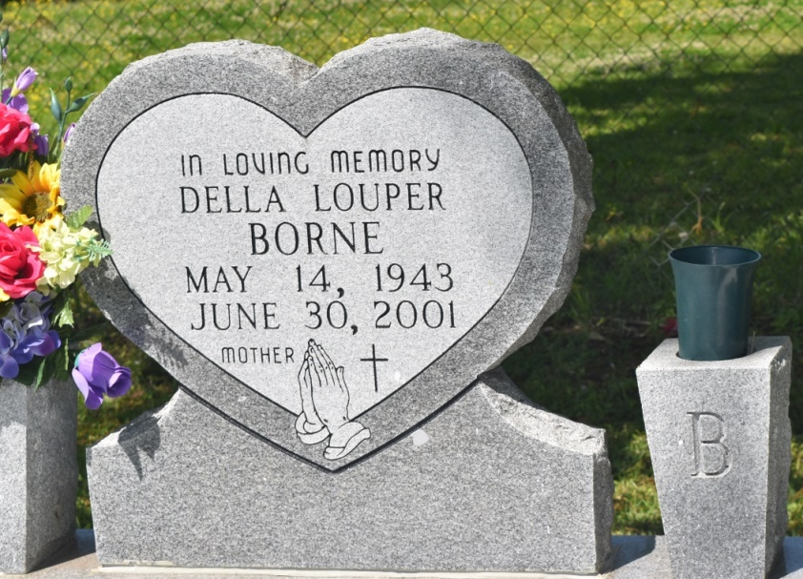

Della Louper Borne, a homemaker, died Saturday of cancer at Leonard Chabert Medical Center in Houma. She was 58. Mrs. Borne was a lifelong resident of Edgard. Survivors include six sons, Ralph Jr., Nakia, Joshua and Desmond Louper, Ellington Borne of LaPlace, and Jeffery Borne of Hahnville; a daughter, Colette Jackson; her parents, Alexis and Beatrice Louper; four sisters, Marion Pierre, Vivian Miller and Ann Johnson, and Lona Shaw of New Orleans; two brothers, Daniel Louper and George Louper of LaPlace; 10 grandchildren; two stepgrandchildren; and a step-great-grandchild. She also was the guardian of Patrick Jackson. A funeral will be held today at 11 a.m. at New Jerusalem Baptist Church. Visitation will begin at 9 a.m. Burial will be New Jerusalem Baptist Church Cemetery. Baloney Funeral Home is in charge of arrangements.

Times-Picayune, The (New Orleans, LA) - Friday, July 6, 2001

Contributed by Jane Edson

*****

EDGARD - Della M. Louper Borne, 58, a native and resident of Edgard, died June 30. She was the former wife of Ralph Borne Sr. and mother of Collette Jackson, Nakia, Joshua and Desmond Louper and Ralph Jr., Ellington and Jeffery Borne. She was also the daughter of Alexis and Beatrice August Louper and sister of Marion Pierre, Vivian Miller, Ann Johnson, Lona Shaw, Daniel and George Louper and the late Rita Fobb and Keith Louper. She is also survived by 10 grandchildren, two step-grandchildren and one step-greatgrandchild. Services were July 6 at New Jerusalem Baptist Church, Edgard, with interment at the church cemetery.

[L'Observateur](http://www.lobservateur.com), LaPlace, LA; July 7, 2001