Jerry Dean (Jackson) Borne

October 17, 1935 – October 31, 2020

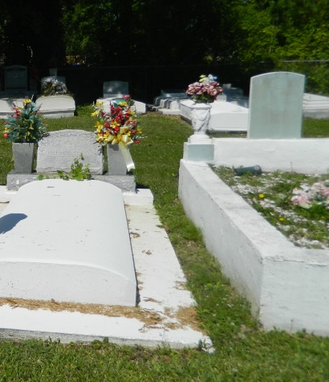

Jesus said to her "I am the resurrection and who believes in me will live, even though he dies; and whoever lives in me will never die." We celebrate the life of our beloved, the matriarch of family and friends, Jerry Dean Jackson Borne. Jerry was born on October 17, 1935 to the union of the late Clara and Henry Jackson, Sr. in St. James, LA. On Saturday, October 31, 2020, she peacefully departed her earthly life and gained her eternal wings at her home surrounded by family. Dean confessed her belief in the Lord Jesus Christ at an early age. She was baptized at St Paul Baptist church in St James, La. During her Christian journey, she served as a Stewart at New Jerusalem Baptist Church under the leadership of Reverend Joseph Johnson until her illness prevented her from attending. Dean was educated in the St James Parish School System. She was a custodial worker at Union Carbide in Taft, LA for over 25 years. She also worked as a private caregiver for over 20 years. Dean leaves to cherish her memory her children Leroy (Cynthia) Foster, Bruce (Debbra) Borne, Lawrence (Myra) Borne, III, Rona Wiltz, Shelia Morris, Joycelyn (James) Thomas, Denise Mason, Donita Bell, Tammy (Rudolph) Sorapuru, Tony (Druhetta) Borne, Brian (Violet) Borne, Desmond (Dionne) Borne, Dyuanne (Shawn) Trench and Laduanne Gautier; 28 grandchildren; 33 great-grandchildren; siblings Henry (Lucy) Jackson, Jr., Roland (Deborah) Jackson and Carolyn Washington; aunt Lilian Preyan, sister-in-law Alice Borne; Goddaughter Darlene Diggs; Godsons Floyd Burke and Dwayne Burke, and a host of nieces, nephews, relatives and friends. She was preceded in death by her husband Lawrence Borne, Jr.; daughter LaVerne Jack; parents Clara Keller and Henry Jackson, Sr.; grandson Izel Dee; brother J. D. Hines (Sarah); aunts Louise Collins and Legia Simon; son-in-law Carlos Morris;; nephew Juan Jackson and Godson Meldon Barnes. In addition, sisters-in-law Lula Belle Keller (Calvin Keller), Sentelia Pierre (Roscoe), Annie Mae Hebron (Bob) and brothers-in-law Jumel Borne (Bernice) and Curtis Borne. Family and friends are invited to attend a celebration of life on Saturday, November 7, 2020 at New Jerusalem Baptist Church, 152 East 6th Street, Edgard, LA 70049. Viewing will be held from 9 am-11 am, followed by a service at 11 am. Entombment at New Jerusalem Baptist Church Cemetery in Edgard, LA. Final care entrusted to Treasures of Life Funeral Services, 315 E. Airline Hwy Gramercy, LA 70052. Masks are required!!

Published in The Times-Picayune (New Orleans, LA) from Nov. 5 to Nov. 7, 2020.