Lester Borne, Sr.
January 16, 1962 – August 26, 2024

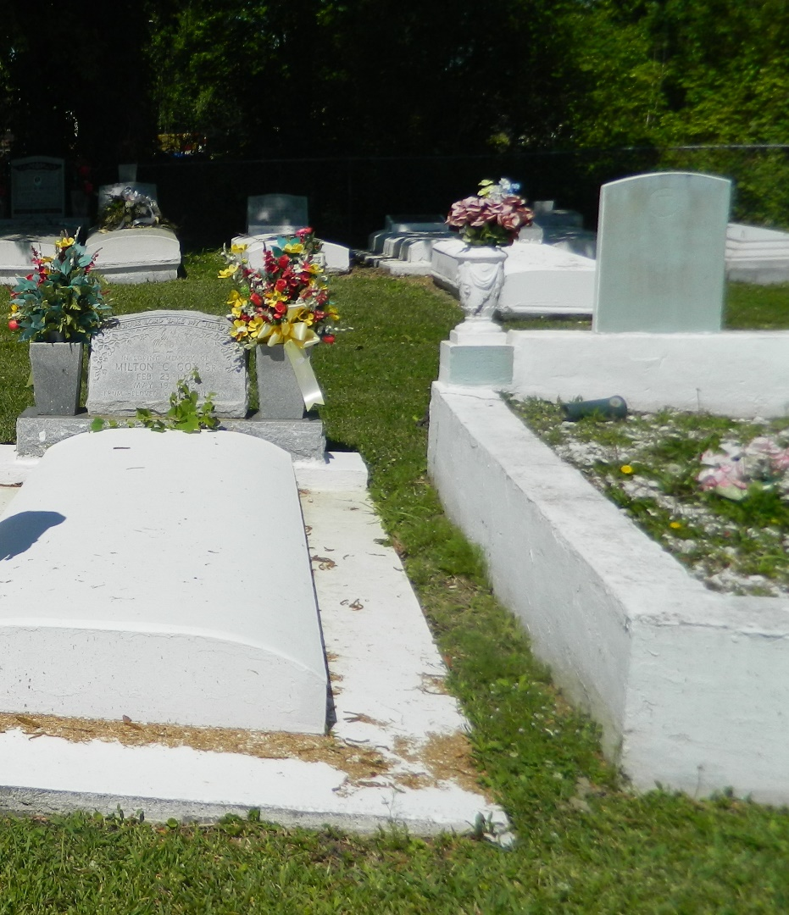

Lester Borne, Sr., beloved father, grandfather, uncle, brother and friend passed away peacefully on August 26, 2024, at the age of 62. Known for his quiet yet observant nature, Lester was a man who deeply cherished the simple joys in life. Lester, a proud native of Edgard, Louisiana, was born on January 16, 1962, to the late McKinley and Velma Bornes (sic).
A lifelong fan of the Pittsburgh Steelers, Lester could often be found cheering on his team with great enthusiasm. He had a love for playing cards, listening to music, and collecting pocket knives. One of his most treasured possessions was his late son’s “Tru Time” bespoke watch collection, which he held close to his heart as a reminder of his son’s legacy. Lester also appreciated the finer things in life, especially good liquor, which he enjoyed in the company of his loved ones and friends.
He leaves behind a legacy of love and memories, survived by his children, Kiara Shavers and Tevin Bornes; his brothers, David (Paulette) Borne, Rudolph (Selina) Bornes, his sisters, Robin Borne, Myra (Alexander) Antonio, and Jennifer Borne; his beloved grandchildren, Tru and Royalty Bornes and a host of nieces, nephews and friends.
He was predeceased by his parents and his two sons, Lester Bornes Jr., and Devin Bornes. Lester's presence will be deeply missed by all who knew him.
A celebration of Lester’s life will be held on Friday, September 6, 2024 at Treasures of Life Funeral Services, 315 E. Airline Hwy, Gramercy, La. 70052 where family and friends will gather to honor his life and legacy. Visitation begins for 12:00(noon) followed by service for 1:00pm. Rev. Sterling White, officiating. Burial will follow at New Jerusalem Baptist Church Cemetery, Edgard, La.

Treasures of Life Funeral Service, Gramercy, Louisiana
September 8, 2024

