Roland Borne Sr.

December 25, 1932 – November 10, 1993

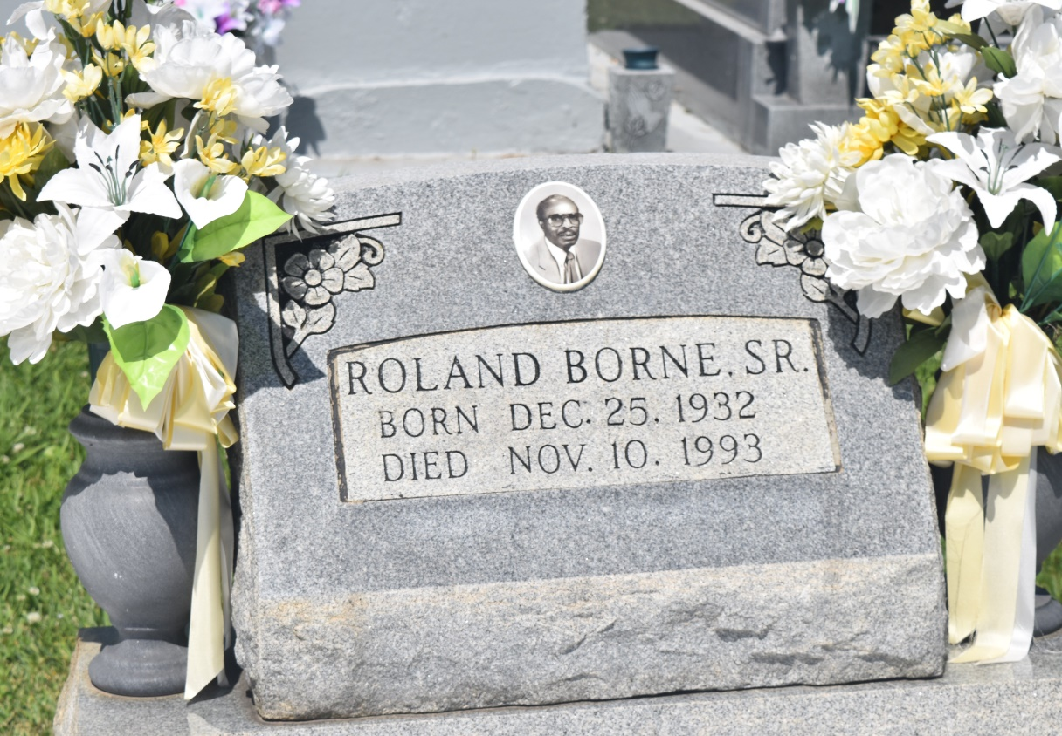

Roland Borne Sr., a state Department of Human Resources examiner, died Wednesday of cancer at his home. He was 60. Mr. Borne, a lifelong resident of Edgard, was a former school teacher and supervisor in St. John the Baptist Parish public schools for more than 32 years. He was a member of Tri-Parish Elks Lodge No. 1764 and a Navy veteran. Survivors include his wife, Selina Jones Borne; two daughters, Valerie Gullage and Lynelle Borne; two sons, Adler Ken Borne and Roland Borne Jr.; three sisters, Ophelia Baloney, Eloise Briscoe and Ollie Hudson; five brothers, Norman, Jonathan, Christopher and Ralph Borne and Romalis Jasmine; and three grandchildren. A wake will be held Sunday at 7 p.m. at New Jerusalem Baptist Church on East Sixth Street in Edgard. A funeral will be held Monday at 11 a.m. at the church, followed by burial in the church cemetery. Earl Baloney & Sons Mortuary is handling arrangements.

Times-Picayune, The (New Orleans, LA) - Saturday, November 13, 1993

Contributed by Jane Edson