Selina (Jones) Borne

April 20, 1938 – August 11, 2005

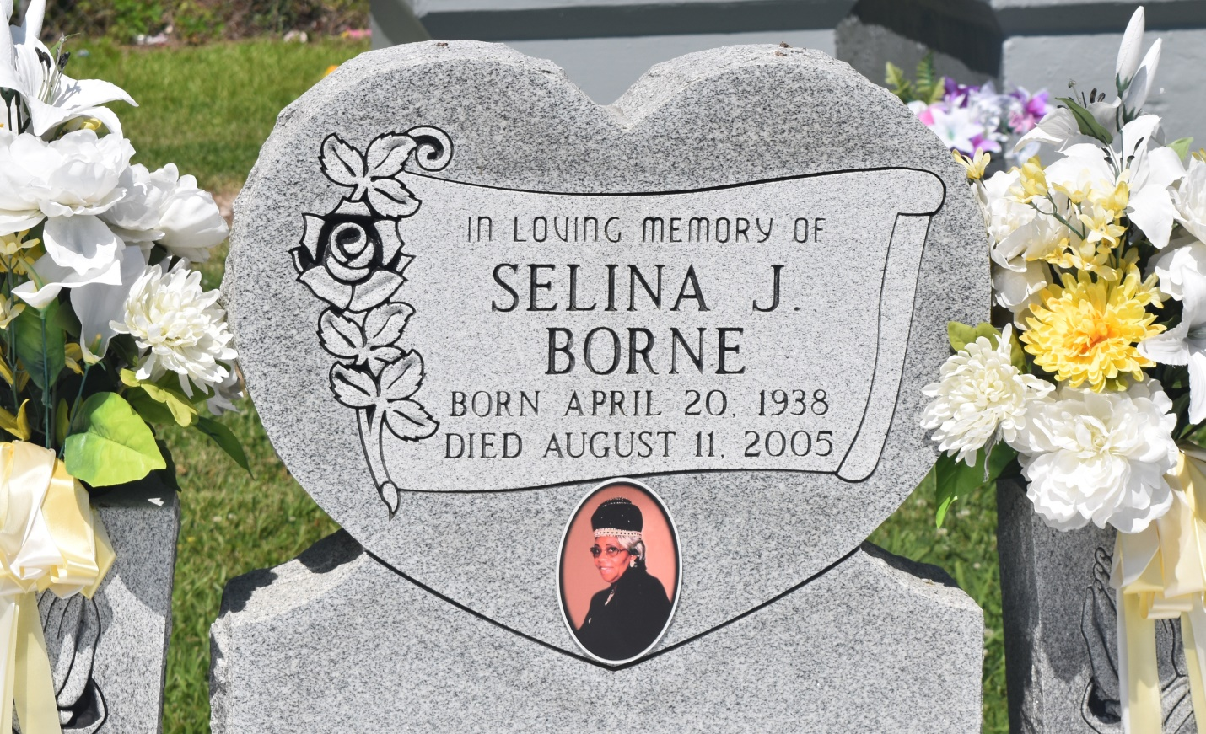

Selina "Mama Lena" Borne, a retired teacher's assistant, died Thursday of cancer at her home. She was 67. Mrs. Borne was a lifelong resident of Edgard. Survivors include two daughters, Valerie B. Gull of Waggaman and Lynelle B. Thomas; two sons, Roland Borne Jr. of LaPlace and Ken Borne; a sister, Loretta Woodfork of Marrero; a brother, Junius Jones Jr. of New Orleans; six grandchildren; and three great-grandchildren. A wake and funeral will be held Sunday at 7 p.m. at New Jerusalem Baptist Church, 152 E. Sixth St., Edgard. Dismissal will be held Monday at 10 a.m. Burial will be in church cemetery. The Baloney Funeral Home is in charge of the arrangements.

Times-Picayune, The (New Orleans, LA) - Saturday, August 13, 2005

Contributed by Jane Edson