Eloise (Borne) Briscoe

March 10, 1926 – February 8, 2011

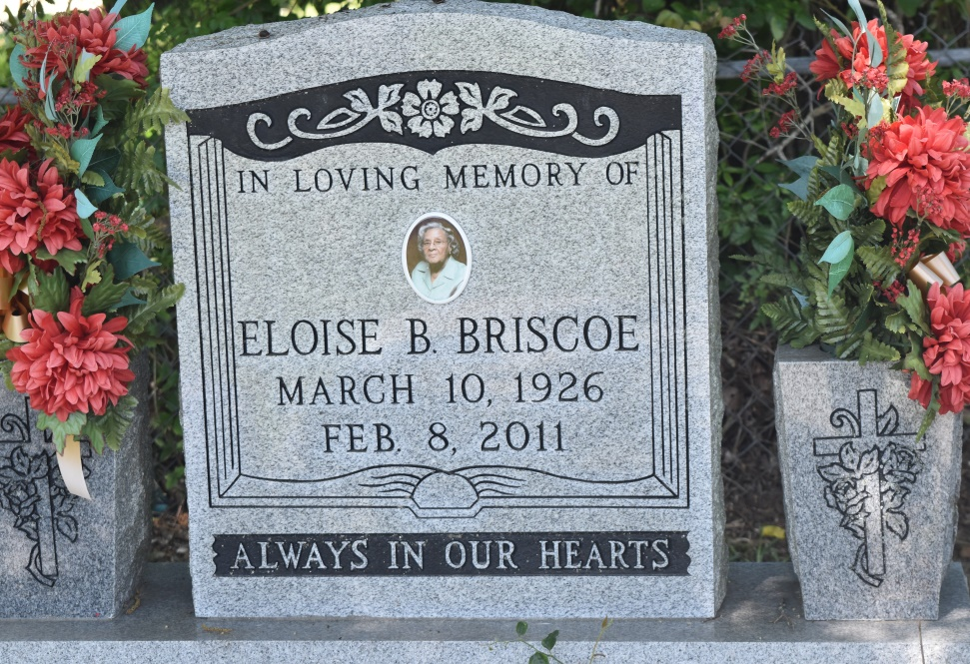

Eloise Borne Briscoe, of New Orleans, Louisiana, at Garyville, Louisiana, at her daughter's residence departed this life on Tuesday, February 8, 2011. Daughter of the late Reverend Urbin and Amy Sylvain Borne. Wife of the late Edward Briscoe Sr. Beloved mother of Debby (Kevin) Marshall, Constance Bazile (Sidney), Edward (Delores), Gregory (Ellen), Keith (Venita), Byron (Doris), Eric (Surnise) Briscoe, Alona (Chester) McDowell, Jeffery Briscoe, and the late Vernell Briscoe. Sister of Ophelia Baloney and the late Romalis Jasmin, Matthew, Isidore, Norman, Roland Sr., Christopher, Ralph, Jonathan Borne, Sr., and Ollie B. Hudson. Niece of Rose Alexander. Also, survived by 21 grandchildren and 20 great grandchildren, a host of nieces, nephews, cousins, other relatives, friends, and host of godchildren. A native of Edgard, Louisiana and a resident of New Orleans, Louisiana. Age 84 years.  
 Relatives and friends of the family, also pastor, officers, and members of Mt. Pilgrim Baptist Church in New Orleans, Louisiana, New Jerusalem Baptist Church in Edgard, Louisiana, True Light Baptist Church in Garyville, Louisiana, Bethlehem Baptist Church in Reserve, Louisiana, 2nd New Guide Baptist Church, Franklin Avenue Baptist Church, and neighboring churches; Employees of Wal-Mart, Eye Surgery Center of La., Oracle, St. John Parish School Board, Amtrack, Louis Armstrong International Airport and U.S. Army are invited to attend the funeral services on Saturday, February 12, 2011 at 12:00 noon from the New Jerusalem Baptist Church, East 6th Street, Edgard, Louisiana, Rev. R. Malone officiating. Visitation begins at the church after 9:00 am. Interment will be in the Church cemetery.  
 Arrangements by The Baloney Funeral Home, LLC, 399 Earl Baloney Street, Garyville, Louisiana 70051, (985) 535-2540. You may sign the guest book at [www.baloneyfuneralhome.com](http://www.baloneyfuneralhome.com/).

Times-Picayune, The (New Orleans, LA) - Friday, February 11, 2011

Contributed by Jane Edson