Kim Edwards

April 3, 1962 – August 21, 2001

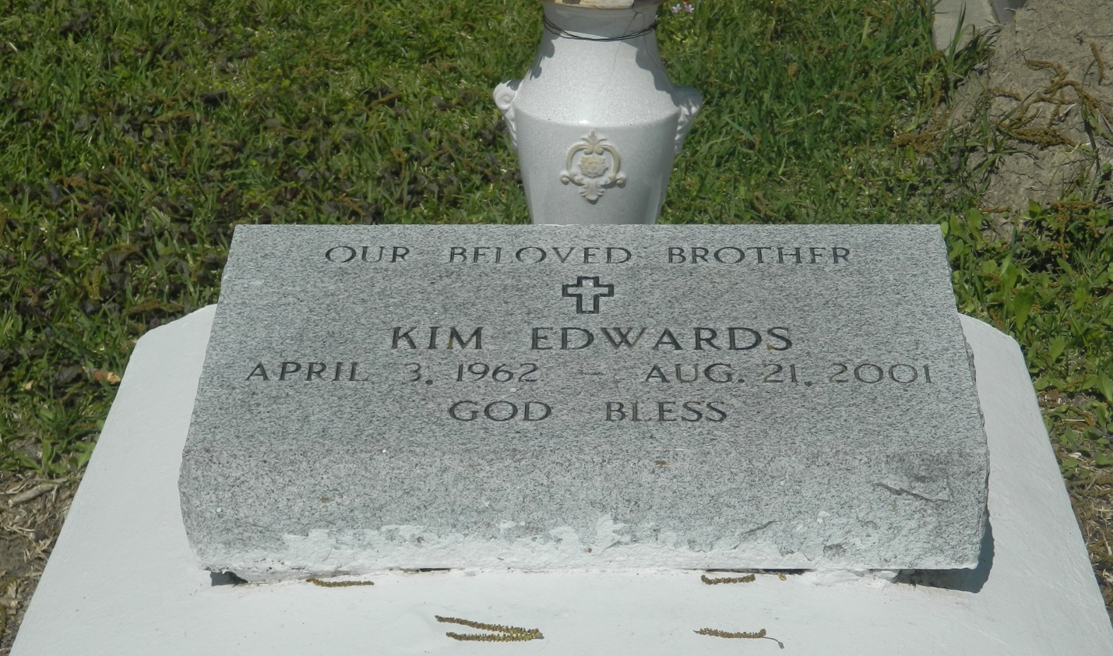

EDGARD - Kim M. Edwards, 39, a native and resident of Edgard, died Aug. 21.

He was the father of Kyle Edwards and Jeremy Morris. He was the son of the late Roy and Florestine Edwards and brother of Patricia Lee, Bridget Pierre, Kentrell and the late Roy Edwards Jr. Services are today at 11 a.m. at New Jerusalem Baptist Church, Edgard, with interment at the church cemetery. Visitation starts at 9 a.m.

L'Observateur, LaPlace, LA; August 25, 2001