Ethel May (Mitt) Gale

September 12, 1941 – June 14, 2002

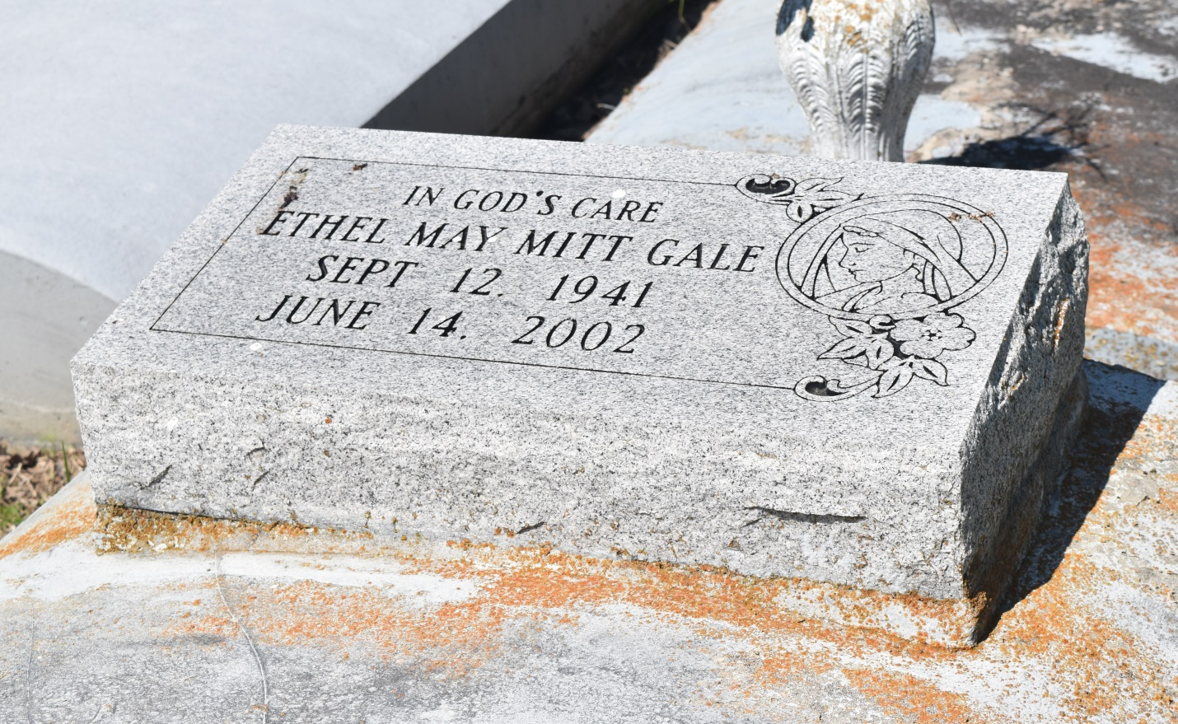

EDGARD - Ethel Mae Mitt Gale, 60, a native of Edgard and resident of Hahnville, died June 14. She was the wife the late Matthew Gale and mother of Elouise, Deborah, Barbara, Dierdra, Darlene, Christina, Matthew Jr., Bobby, Mark and Conrad Mitt.  
  
She was the daughter of Sedonia and the late Robert Mitt Sr. and sister of Rosemary Bradford, Lucy Strickland and Robert Jr., Albert and Joseph Mitt.  
  
She is also survived by 25 grandchildren and one great-grandchild.  
  
Services are today at 11 a.m. at New Jerusalem Baptist Church, Edgard, with interment at the church cemetery. Visitation starts at 9 a.m.

L'Observateur (La Place, LA) - Wednesday, July 3, 2002

Contributed by Jane Edson