Laverne (Jasmine) Jack
October 9, 1950 – April 24, 2009

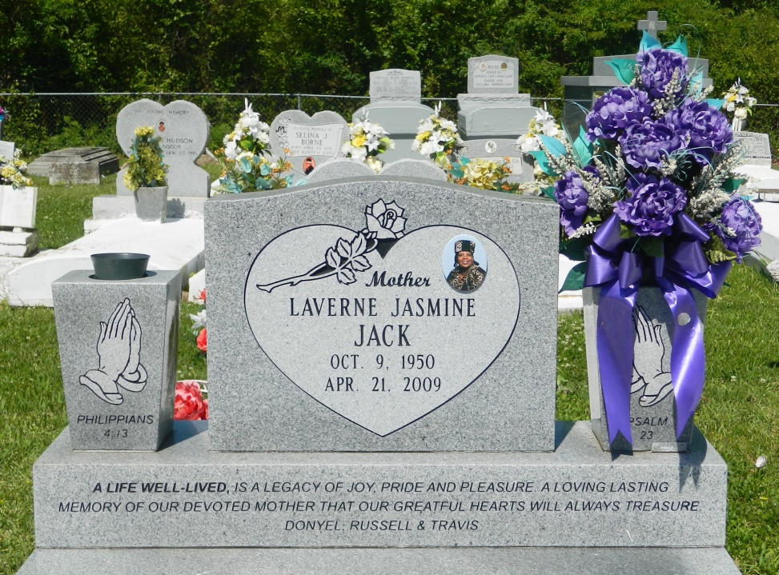

Laverne "Lee" Jasmine Jack on Tuesday, April 21, 2009 at Kindred Hospital in Houston, TX, peacefully went home to the with the Lord. She was the daughter of Orelia J. Wright and Lawrence Borne, Sr. and was reared by the late Thomas and Lillian Jasmine. Stepdaughter of Geraldine Borne and the late John Wright, Sr. Wife of Russell Jacks, Sr. Mother of Donyel Sherie, Russell Jr. and Travis Jude Jack. Grandmohter of Alexia and Eric Jr. Sister of thirty brothers and sisters: Leroy, Thomas, Alton, Nathaniel, Bruce, Lawrence, John, Allen, Tommy, Mark, Brian, Desmond, David, Enola, Shirley, Marion, Myrtle, Linda, Madeline, Joslyn, Rona, Shelia, Denise, Joyce, Betty, Donita, Tammy, Valerie, Alicia, LaDy'anne and Dyuanne, the late Antoine, Cynthia and Janice. Niece of Marjoire Bailey and Curtis Borne. Preceded in death by godmother, Julia Gross. Laverne is survived by a host of nieces, nephews, other relatives and friends. Age 58. A native and resident of Edgard, LA.
Relatives and friends of the family, also pastor, officers and members of New Jerusalem Baptist Church and all neighboring churches, Shell Chemical, St. John the Baptist School Board and Council are invited to attend the Funeral Services at the above named Church on Saturday, April 25, 2009 at 11:00 a.m. and a Musical Celebration on Friday, April 24, 2009 from 7:00 - 9:00 p.m.
Services by BALONEY FUNERAL HOME, L.L.C., 399 Earl Baloney Dr., Garyville, LA.
Information: (985) 535-2540 In Charge of Arrangements

Times-Picayune, The (New Orleans, LA) - Friday, April 24, 2009
Contributed by Jane Edson

