Norris Johnson Jr.

September 29, 1945 – July 17, 2014

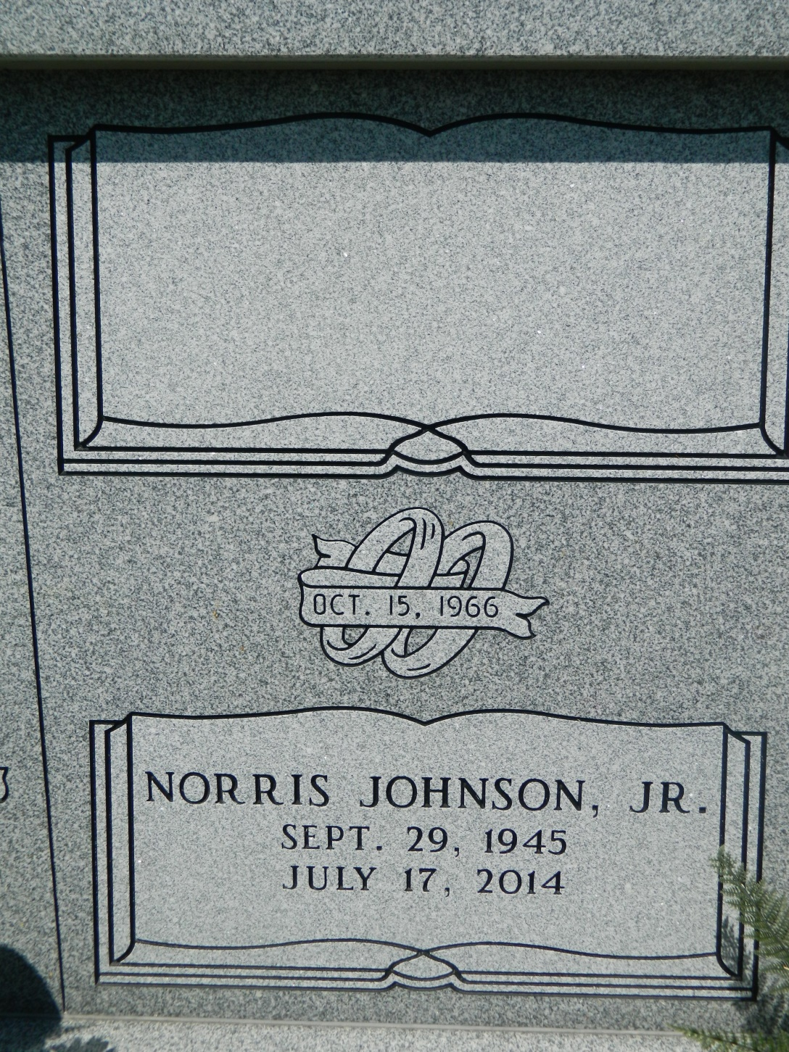

Norris "Pee Wee" Johnson Jr. departed this earthly life and entered into eternal rest on Thursday July 17, 2014 at St. Charles Parish Hospital of Luling, La. Preceded in death by his parents, Rosa and Norris Johnson Sr. Beloved Husband of Shirley Narcisse Johnson. Loving Father of Pastor Monica (Brian) Lewis, Norris (Martha) Johnson III, Nakeela (Freddie) Young and Duston Johnson. Brother of Michael (Virgie) Johnson and Arthur Johnson. Brother-in-law of Earl (Yvonne) Jasmine, Olivia (Norman) Dillon, and Catherine Thomas. Also survived by 10 grandchildren and a host of nieces, nephews other relatives and friends. A lifelong resident of Edgard, La.  
  
Relatives and friends of the family, Pastors, Officers and members of New Jerusalem Baptist Church of Edgard, La., Class of 1965, St. John Housing Authority, Boutte Christian Academy, JPCU, PFG Performance and all neighboring churches are invited to attend the celebration of life service on Saturday July 26, 2014 at 11:00 am at New Jerusalem Baptist Church 152 East 6th St. Edgard, La. where the Pastor is Rev. Maurice Tillman. Pastor Monica Lewis will officiate. Visitation will be from 9:00 am until service time at the above named church. Burial will be in the church cemetery.  
  
Bardell's Mortuary of Mt. Airy, La in charge. Information: 985-535-6837.

Times-Picayune, The (New Orleans, LA) - Friday, July 25, 2014

Contributed by Jane Edson