Linda (Jasmine) Samuel

September 5, 1943 – June 26, 2013

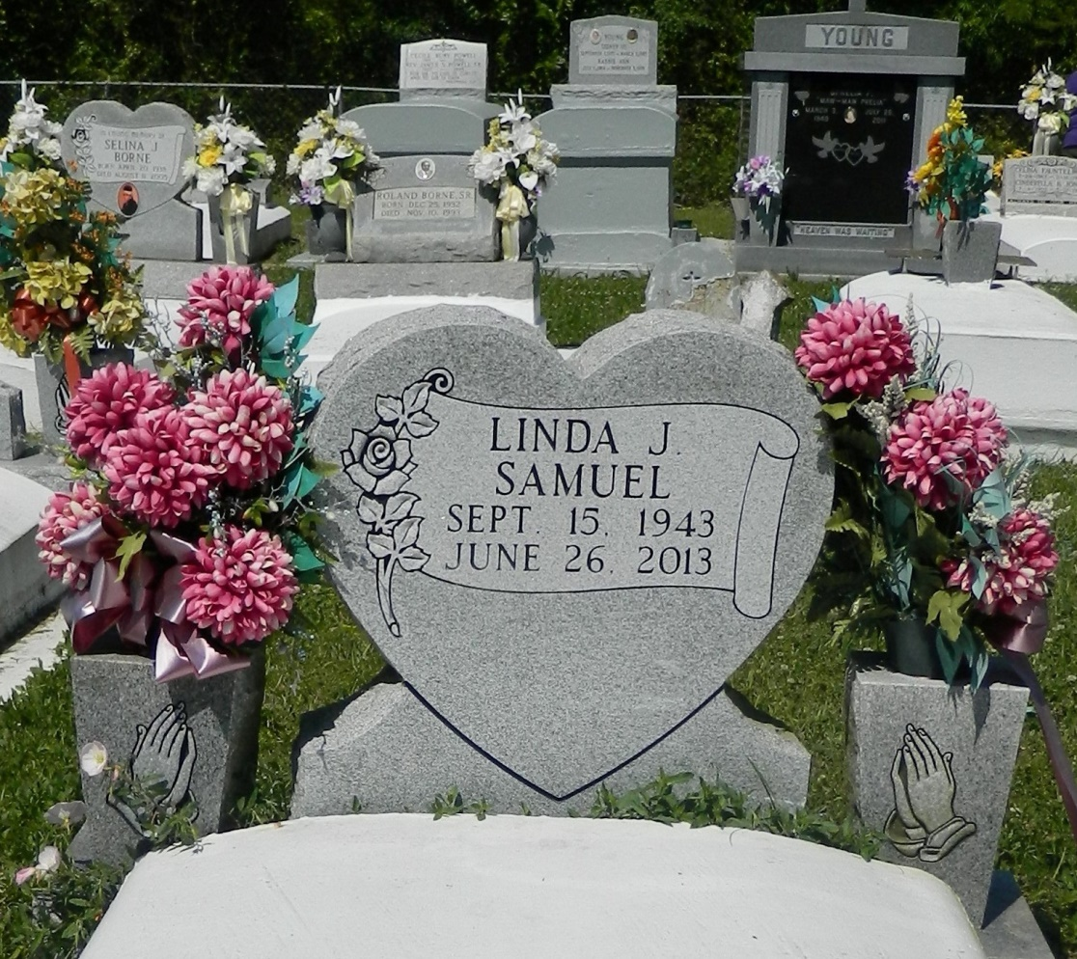

Linda Jasmine Samuel, a native of Edgard, La., departed this life on Wednesday, June 26, 2013. Daughter of the late Thomas and Lillian Jasmine. Beloved wife of Anthony Samuel. Mother of Charles Samuel and Racquel Samuel (Keith) Bruce. Grandmother of Kimmeka, Kierra and Charles Samuel, II and Erris Bruce. Sister of Orelia Wright, Enola Allen, Shirley Thomas, Marion Feist, Myrtle Walker, Thomas, Alton and Nathaniel Jasmine, Madeline Bourgeois, Joslyn Gastearl and the late Janice Lumar, Cynthia Tompkins, Antoine Jasmine, and Laverene Jack. Mother-in-law of Kimberly Samuel. Also survived by a host of nieces, nephews, cousins, other relatives and friends.  
 Relatives, friends and employees of Avondale Shipyard are invited to attend the funeral services at New Jerusalem Baptist Church, 152 East 6th Street, Edgard, La., on Wednesday, July 3, 2013 for 11:00 a.m. Rev. K. Maurice Tillman will be officiating. Visitation will be from 9:00 a.m. until time of service. Interment will be at New Jerusalem Baptist Chruch, Edgard, La. Funeral entrusted to The Baloney Funeral Home, LLC, 1905 W. Airline Highway, Laplace, La.  
 Condolences can be expressed at [www.baloneyfuneralhome.com](http://www.baloneyfuneralhome.com/).

Times-Picayune, The (New Orleans, LA) - Sunday, June 30, 2013

Contributed by Jane Edson