Jessel S. Smith Sr.

March 9, 1927 – January 27, 2008

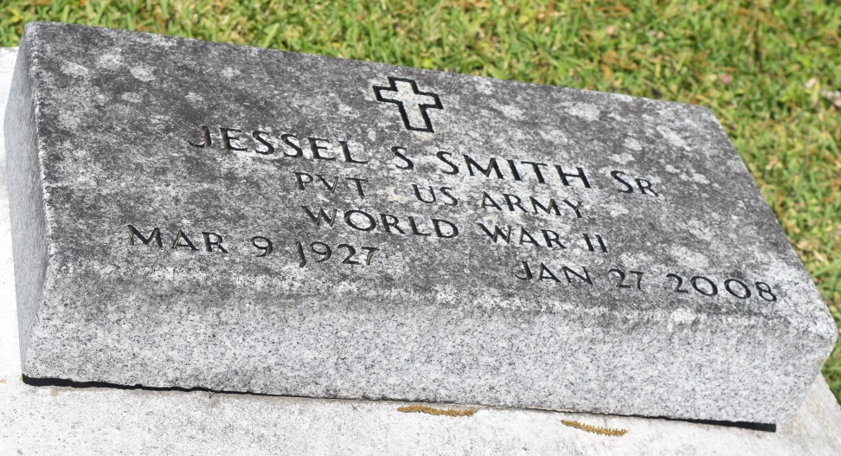

Jessel (Dee Da)(Rev) Smith, Sr. of Edgard La. at his residence on Sunday, January 27, 2008 entered into eternal rest. Son of the late Rev. Landry C. Smith and Victoria Herbert Smith. Husband of the late Eunice Samuel Smith. Father of Terry (Denine) Smith Sr., Linda (Felix) Dumas, Gail (Rev. Joseph) Comminie, Monna (Timothy) Green, Donald "Bum" (Lesia) Smith, Yolanda S. Johnson and the late Jessel Smith Jr., former father-in-law of Patricia Smith Ballansaw. Brother of Mildred, Joseph Smith, Elsie Mullins and the late Hazel Landry, Fannie Lewis, Victoria Barnes, Earline Johnson, Landry, Lawrence, Enix, Ellis, Richard, and Arthur Smith. Also survived by a host of grandchildren, and great grandchildren, nieces, nephews, cousins, other relatives and friends. A native of Wallace, La. and a resident of Edgard, La. Age 80 years.

Relatives and friends of the family, also pastor, officers, and members of the New Jerusalem B.C., St. John the Baptist Catholic Church, New Home Minister, Faith, Praise and Deliverance Temple, and neighboring churches; Bonsecour Society Employees of St. John Parish School System, Oschner Medical Center-Kenner, Huber Corp., West St. John High School Band Booster, River Parish Times Picayune Bureau, Ascension Parish School Board, H & R Block, Orleans Parish School Board, Pinnacle Polymers and Greater New St. Peter B.C. are invited to attend the funeral services on Saturday, February 2, 2008 at 11:00am from the New Jerusalem B.C., East 6th St., Edgard, La. Rev. Dr. Joseph Johnson officiating. Interment church cemetery. Visitation at the church after 9:00am on Saturday.  
 The Baloney Funeral Home LLC, 399 Earl Baloney Dr., Garyville, La. 70051, 985-535-2540   
In Charge of arrangements

Times-Picayune, The (New Orleans, LA) - Friday, February 1, 2008

Contributed by Jane Edson