Betty Ann Songy

October 7, 1945 – July 8, 2002

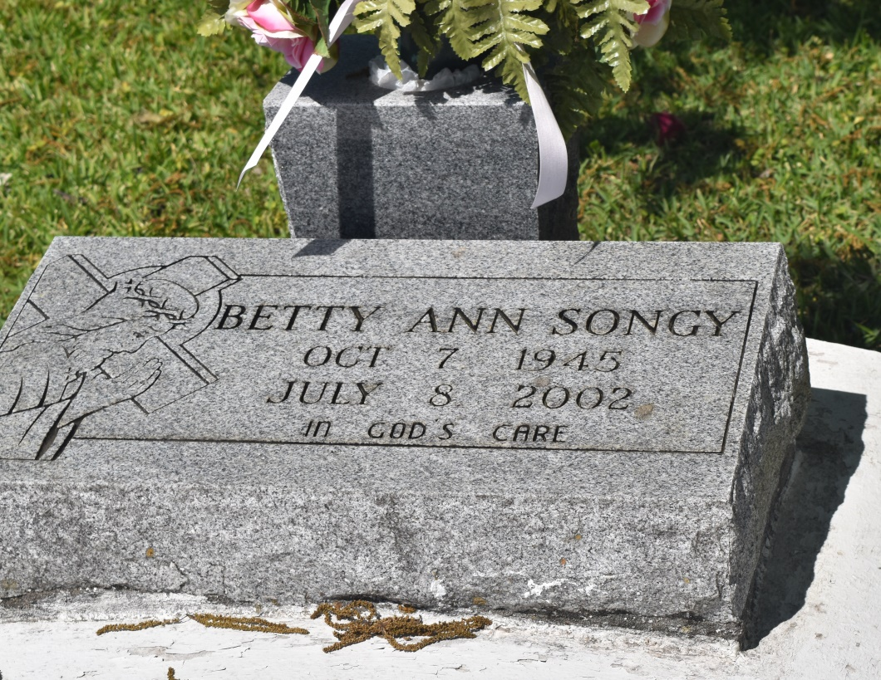

Betty Ann Songy, at Wallace, LA on Monday, July 8, 2002. Daughter of Victoria Songy and the late Prudent Songy. Mother of Terry Benton of San Jose, CA and the late Roderick Mitchell. Sister of Nelson Jordan, Leslie Scriven, Troy and Trent Griffin and the late Danny Griffin. Devoted cousin of Florence Bastain. Grandmother of Candace Mitchell and Roderick, Jr. Also survived by a host of nieces, nephews, cousins and friends. A native of Edgard, and a resident of San Jose CA and New Orleans for many years. Age 56 years.  
  
Relative and friends of the family, also Priest and Parishioners of St. Phillip Catholic Church, St. John the Baptist Catholic Church, New Jerusalem Baptist Church and neighboring churches are invited to attend a Mass of Christian Burial on Saturday, July 13, 2002 at 10:00 AM from the St. Phillip Catholic Church, Vacherie, LA. Father David Chauvin, Celebrant. Interment New Jerusalem Baptist Church Cemetery, Edgar, LA. Visitation after 8:00 AM. Rosary at 9:00 AM.  
  
THE BALONEY FUNERAL HOME IN CHARGE OF ARRANGEMENTS

Times-Picayune, The (New Orleans, LA) - Friday, July 12, 2002

Contributed by Jane Edson