Louis Young

March 5, 1927 – August 27, 2001

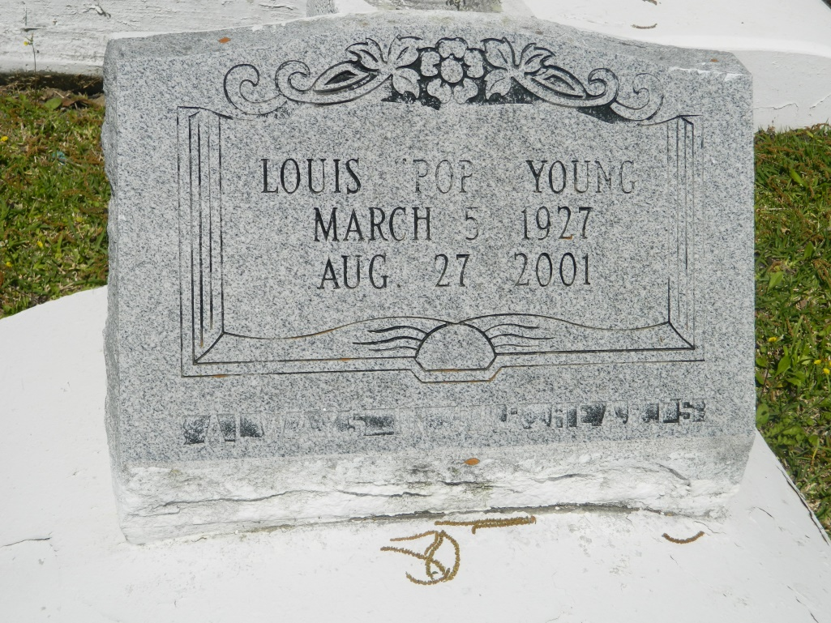

Louis (Lolly Pop) Young of Edgard, La. on Mon. Aug. 27, 2001 at St. Charles Hospital, Luling, La. Son of the late Joseph & Rella Roussell Young. Brother of Gladys Gray of LaPlace, LA and the late Sidney Young, Sr., Pearl Y. Lumar, Freddie Dave Young, Ethel Y. Reese, Alma Y. Goodin, Joseph Young, Jr. Ferdinand Young & Rosa Y. Johnson. Brother-in-law of Warine & Lorraine Young. Devoted caregiver Eula Young of Edgard, LA. Also survived by a host of nieces, nephews, cousins & friends. A native and resident of Edgard, LA Age 74 yrs.  
 Relatives and friends of the family, also pastor, officers & members of the New Jerusalem B.C. Greater New St. Peter B.C., St. John the Bapt. Catholic Church, Edgard, LA, Greater Antioch Full Gospel Church of New Orleans & neighboring churches. Members of Mayflower Society. Employees of St. John Parish Assessor's Office, Housing Authority, Library & Utilities, Dow Chemical & Dupont are invited to attend the funeral services on Sat. Sept. 1, 2001 at 11:00 AM from the New Jerusalem B.C. Edgard, LA. Rev. Joseph Johnson officiating. Interment church cemetery. Visitation at the church after 9:00 AM on Sat. (NO WAKE). The Baloney Funeral Home in charge of arrangements.

Times-Picayune, The (New Orleans, LA) - Friday, August 31, 2001

Contributed by Jane Edson

\*\*\*\*\*

EDGARD - Louis "Lolly Pop" Young, 74, a native and resident of Edgard, died Aug. 27. He was the son of the late Joseph and Rella Roussell Young and brother of Gladys Gray and the late Pearl Lumar, Ethel Reese, Alma Goodin, Rosa Johnson and Sidney Sr., Freddie, Joseph Jr. and Ferdinand Young. Services are today at 11 a.m. at New Jerusalem Baptist Church, Edgard, with interment at the church cemetery. Visitation starts at 9 a.m.

L'Observateur, LaPlace, LA; September 1, 2001