Brenda Joyce (Wilson) Anderson

August 9, 1951 – October 7, 2007

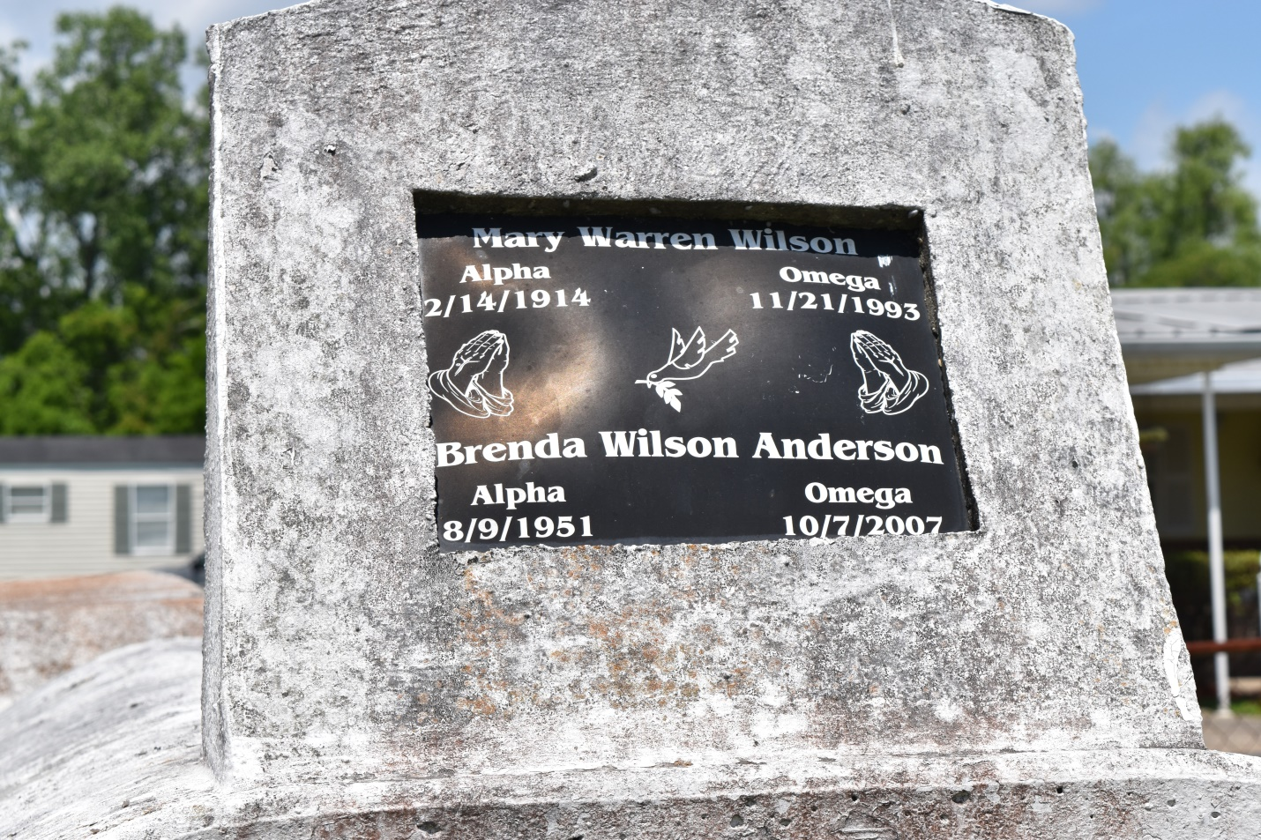

Brenda Joyce Wilson Anderson, Age 56, departed this life on Sunday October 7, 2007 in Laplace, La., Daughter of the late Joseph and Mary (Warren) Wilson, Wife of Joseph Anderson, Sr., Mother of Joseph, Jr., Walanda, Willie, Terrylynn, and Selina Anderson, Sister of Louberta Selder, Victoria and James Wilson, also survived by 10 Grandchildren,, and a host of nieces, nephews, other relatives. A native and resident of Laplace, La.

Pastors, and Members of Beech Grove Baptist Church and all Neighboring Churches, are invited to attend the funeral service on Saturday October 13, 2007 at 11:00a.m., from the above named church, 117 Beech Grove Dr., Reserve, La., Rev Wesley Anderson, Sr., pastor Officiating, Interment in Zion Travelers Cemetery (sic), Reserve, La. Visitation at the church from 9 a.m. until Service Time.  
  
Service Entrusted to Hobson Brown Funeral Home, Garyville, La.

Times-Picayune, The (New Orleans, LA) - Friday, October 12, 2007

Contributed by Jane Edson