Junius J. Breaux

August 27, 1943 – December 7, 2002

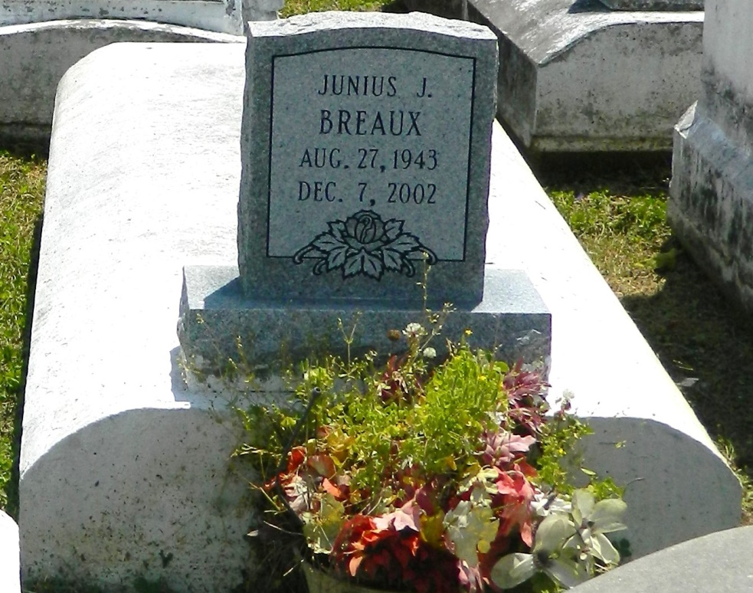

Junius Joseph "J.J." Breaux, a retired Marine sergeant and a veteran of the Vietnam War, died Dec. 7 of undetermined causes at Veterans Affairs Medical Center. He was 59. Mr. Breaux was born in LaPlace and lived in California for many years before moving back to LaPlace. Survivors include three daughters, Semeco Breaux of Destrehan, and Tiffany Breaux and Stephanie Breaux of California; six sisters, Martha Parquet and Audrey Johnson, Thelma Francis of New Orleans, Irene and Louise Breaux, and Alma Fuller of California; a brother, Herman Breaux of Reserve; and five grandchildren.

A funeral will be held Monday at 11 a.m. at New Vision Missionary Baptist Church in LaPlace. Visitation will begin at 9:30 a.m. Burial will be in Providence Resthaven Cemetery in LaPlace. Hobson Brown Funeral Home is in charge of arrangements.

Times-Picayune, The (New Orleans, LA) - Sunday, December 15, 2002

Contributed by Jane Edson