Lawrence Breaux, Jr.
June 6, 1949 – October 1, 2003

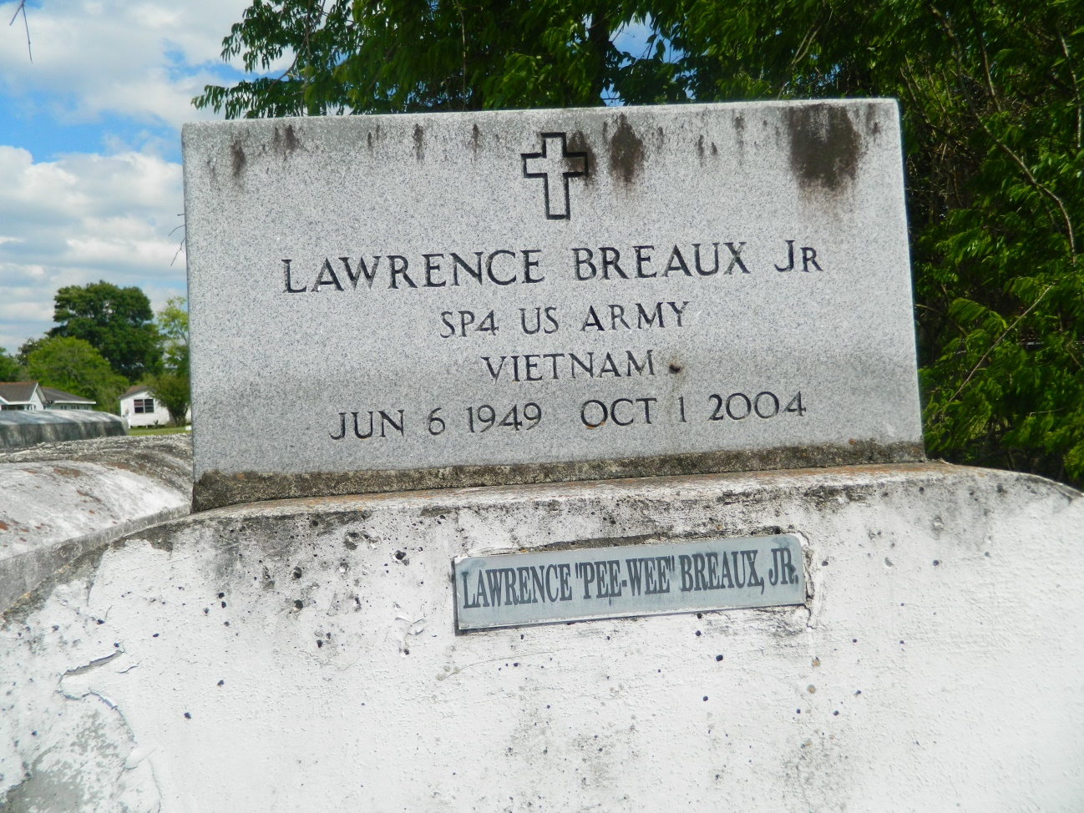

Lawrence "Pee Wee" "Curly" Breaux Jr., a truck driver for Carriage Meat Co., died Friday of cancer at St. Charles Parish Hospital. He was 55. Mr. Breaux was a lifelong resident of LaPlace. Survivors include his son, Jarvis Breaux; three daughters, Lillian and Lydia Breaux, and Nikita Tobias; his mother, Mary Lee Noble Breaux; two brothers, Bruce and Branhigan Breaux; and six grandchildren. A funeral will be held today at 10 a.m. at Providence Baptist Church No. 1 at 240 Pine St. in LaPlace. Burial will be in Providence Rest Haven Cemetery in LaPlace. Hobson Brown Funeral Home is in charge of arrangements.

Times-Picayune, The (New Orleans, LA) - Thursday, October 7, 2004
Contributed by Jane Edson

