Deforest Marie “Dee” Brown

October 3, 1940 – March 23, 2004

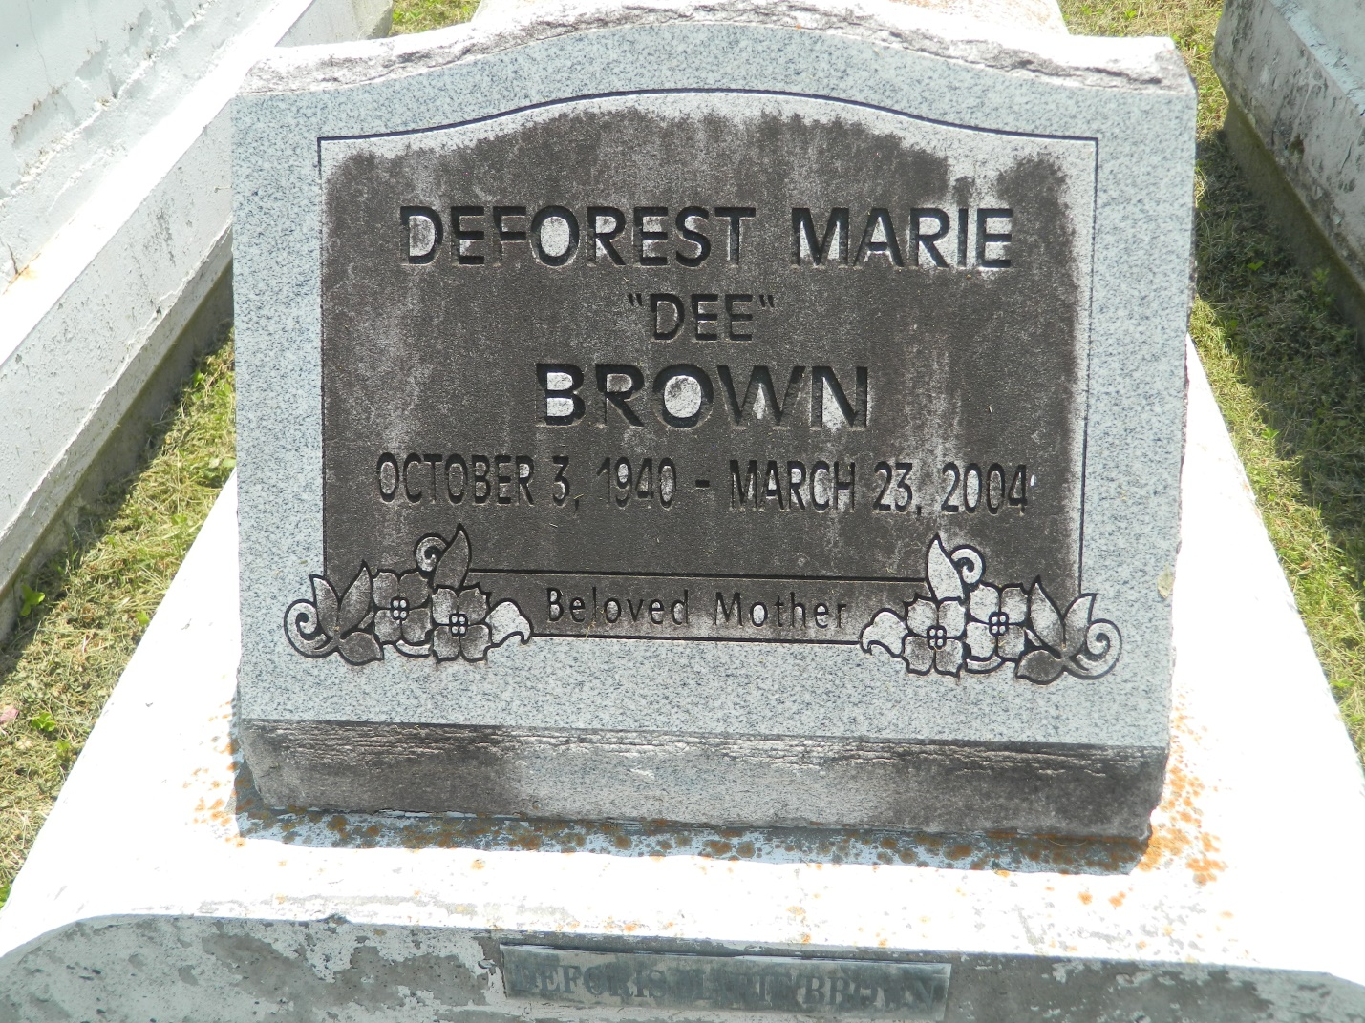

LAPLACE - Deforest Marie (Dee) Brown, 63, a native and resident of LaPlace, died March 23. She was the mother of Judge Penny Brown Reynolds, A'yango Brown, Keisha Brown and Monica Brown Mealey.  
  
She was the daughter of the late Roy and Blanche Brown and sister of Burnell Harris, Reno, Randell and Lionel Brown, Blanche Cambre, Sylvia Scott and Theresa Williams.  
  
She is survived by three grandchildren.  
  
Services are today at 11 a.m at Mt. Calvary Baptist Church, LaPlace with interment in Providence Rest Haven Cemetery, LaPlace. Visitation starts at 9 a.m.

L'Observateur (La Place, LA) - Sunday, March 28, 2004

Contributed by Jane Edson