Victoria (Sterling) Carter

October 7, 1922 – July 1, 2003

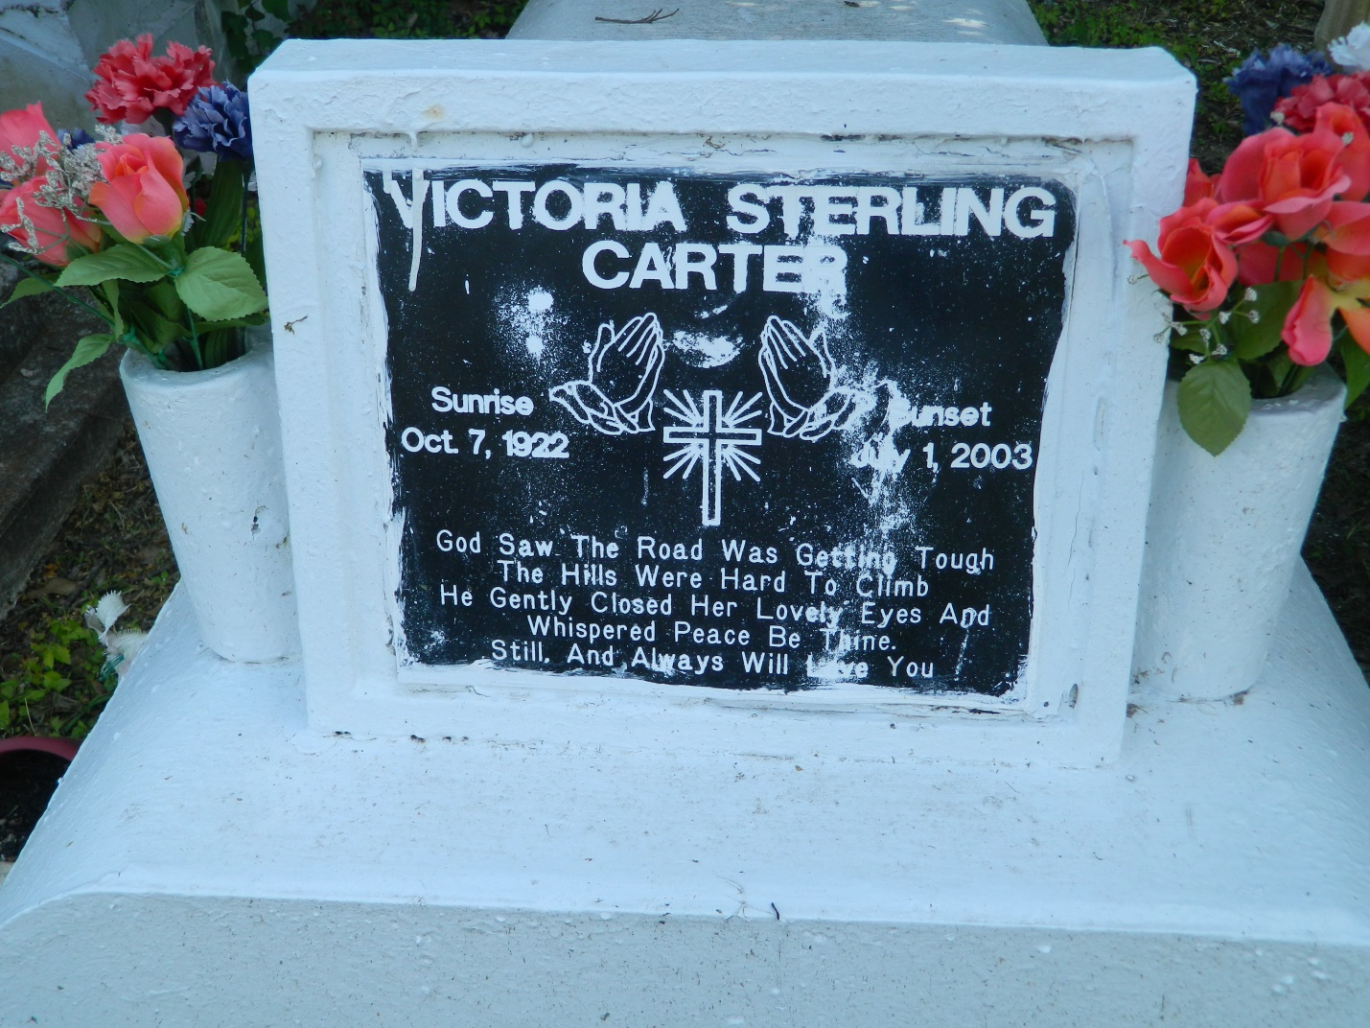

Victoria "Miss Meal" Carter, a retired cook, died Tuesday at Metropolitan Hospice of cancer. She was 80. Ms. Carter was a lifelong resident of LaPlace.

Survivors include four sons, Ronald, Richard, Walter and Tommie Carter; a daughter, Neomia Rhodes of Arizona; 18 grandchildren; and nine great-grandchildren.

A funeral will be held Saturday at 11 a.m. at Mount Calvary Baptist Church, 127 W. 3rd St., LaPlace. Visitation is at 9 a.m. Burial will be in Providence Rest Haven Cemetery in LaPlace. Hobson Brown Funeral Home is in charge of arrangements.

Times-Picayune, The (New Orleans, LA) - Friday, July 4, 2003

Contributed by Jane Edson