Alvin Joseph Cook, Sr.

January 4, 1934 – May 27, 2004

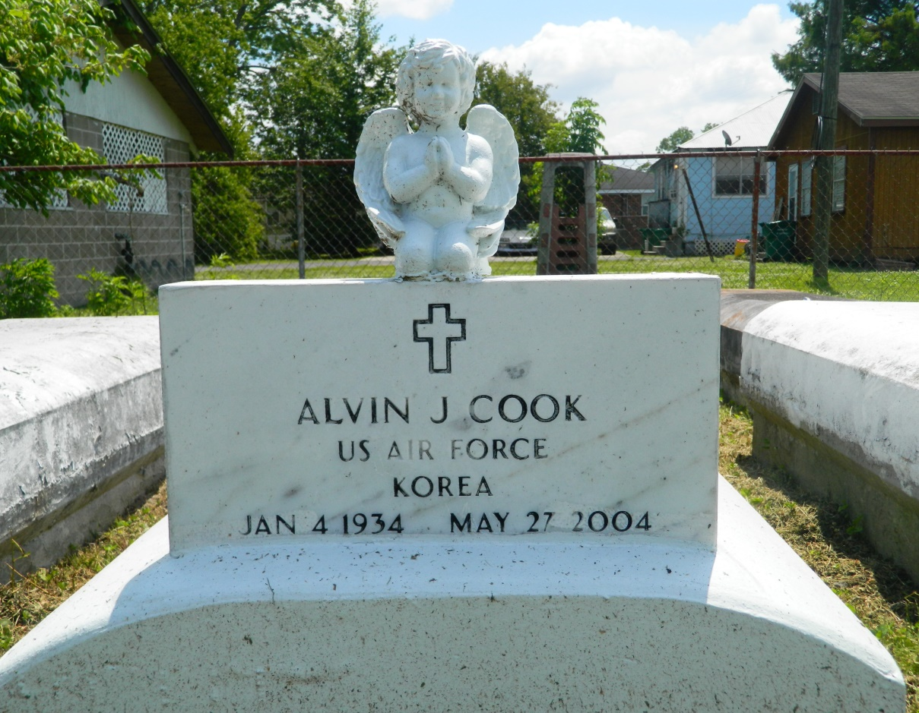

Alvin Joseph Cook Sr., a retired laborer, died Thursday of congestive heart failure at Veterans Affairs Medical Center. He was 70. Mr. Cook was born in Reserve and lived in LaPlace. He served in the Air Force. Survivors include his wife, Bessie Smith Cook; seven sons, Alvin Cook Jr., Gregory Cook and Richard, Darryl, Wilfred, Michael and Uray Johnson; three daughters, Janice C. Joseph, Rita Mack and Regina C. Easley; three brothers, Oscar Cook Jr. and Henry and Elmo Cook; three sisters, Marie C. Stevenson, Veronica C. Bailey and Goldie C. Wilkens; 12 grandchildren; and four great-grandchildren.

A Mass will be said Monday at 11 a.m. at Our Lady of Grace Catholic Church, 772 River Road in Reserve. Visitation will begin at 9 a.m. Burial will be in Providence Rest Haven Cemetery in LaPlace. Robottom Mortuary is in charge of the arrangements.

Times-Picayune, The (New Orleans, LA) - Saturday, May 29, 2004

Contributed by Jane Edson