Kerion K. Dennis

July 24, 1971 – April 5, 2011

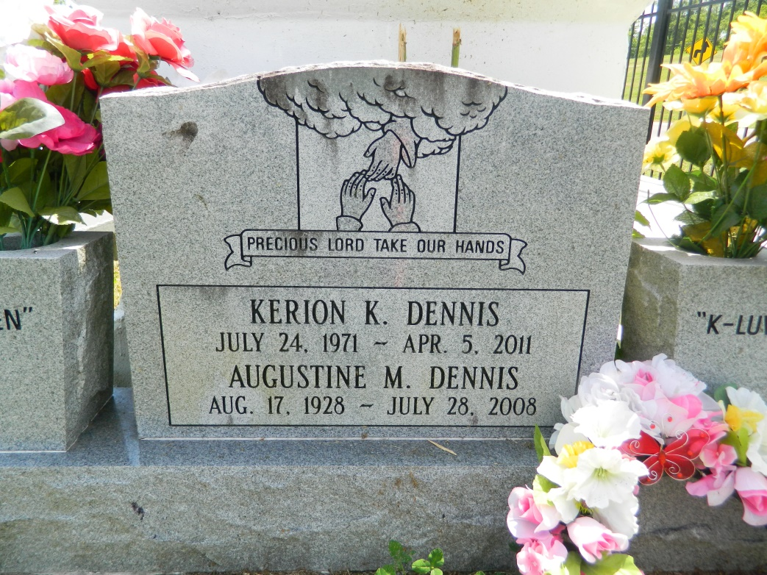

Keiron K. Dennis on Tuesday, April 5, 2011 in Baton Rouge, Louisiana. Son of Diane Dennis Jackson. Husband of the late Karen Stewart Dennis. Devoted friend of Shawanda Chews. Father of Kamisha Stewart, Keira Dennis, Keiron Dennis, Jr., Keirmeshia Dennis, Keinesha Vinnett, and Lasha Carter. Stepfather of Keresima Stewart, Desmond Stewart, Marquixha Chews, Tyrone Jackson and Devante Chews. Brother of Cardera and Corey Dennis. Step-brother of Faye LaBiche, Jean Stewart, Min. Rodney Nicholas, Lori Keller, Erica Cola, Michelle Watkins, Shannon Webster, Sherrie Winston and the late Myron Nicholas. Also survived by a host of aunts, uncles, nieces, nephews, other relatives and friends. Age 39 years. A native of LaPlace, LA and a resident of Baton Rouge, LA.  
  
Relatives and friends of the family, also pastors, officers and members of Mt. Calvary Baptist Church and all neighboring churches are invited to attend the funeral at Mt. Calvary Baptist Church, 127 West Third Street, LaPlace, LA on Saturday, April 9, 2011 at 12:00 noon. Pastor Freddie Howard, Officiating. Interment Resthaven Cemetery, LaPlace, LA.  
  
SERVICED BY ROBOTTOM

Times-Picayune, The (New Orleans, LA) - Friday, April 8, 2011

Contributed by Jane Edson