Marion Dennis

March 22, 1952 – July 25, 2004

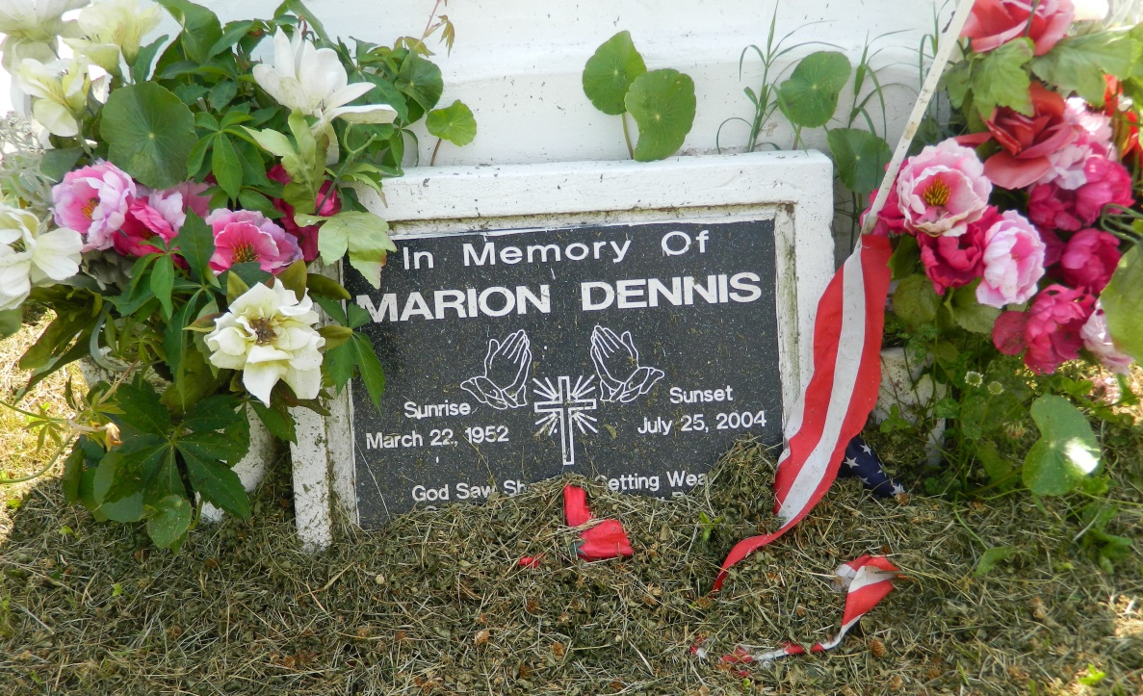

Marion Dennis, a homemaker, died July 25 of heart failure at Tulane University Hospital. She was 52. Mrs. Dennis was born in New Orleans and lived in LaPlace. Survivors include a son, Timothy Dennis; three brothers, Gary Millet, Durward Smith and Irvin Dennis Jr.; five sisters, Barbara and Adaline Dennis, Diane Jackson, Latricia Adams and Ceola Gerard; and three grandchildren. A funeral will be held Saturday at 10 a.m. at Providence Baptist Church, 240 Pine Street, LaPlace. Visitation will begin at 9 a.m. Burial will be in Providence Resthaven Cemetery. Robottom Mortuary is in charge of the arrangements.

Times-Picayune, The (New Orleans, LA) - Friday, July 30, 2004

Contributed by Jane Edson