Shirley Mae (Fortier) Dennis

May 13, 1935 - December 29, 2002

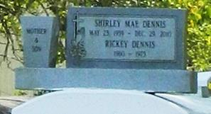

Shirley Mae Fortier Dennis, a homemaker, died Friday of congestive heart failure at Pendleton Memorial Methodist Hospital. She was 67. Mrs. Dennis was a lifelong resident of New Orleans. She was a member of Sixth Union Baptist Church. Survivors include her husband, Louis B. Dennis Sr.; five sons, Louis Dennis Jr. and Michael, Dave, Antoine and Brian Dennis; seven daughters, Cheryl Ganier, Adrain Carter, Sandra Boykins, Gaynell Pounds, Toni Duplessis, Michele Armstrong and Della Dennis; 34 grandchildren; and 43 great-grandchildren. A funeral will be held Thursday at 11 a.m. at Boissiere-Labat Family Funeral Services, 1703 N. Claiborne Ave. Visitation will begin at 9 a.m. Burial will be in Providence Memorial Park.

Times-Picayune, The (New Orleans, LA) - Wednesday, June 26, 2002

Contributed by Jane Edson