Audrey M. (Johnson) Ester

April 6, 1935 – April 24, 2002

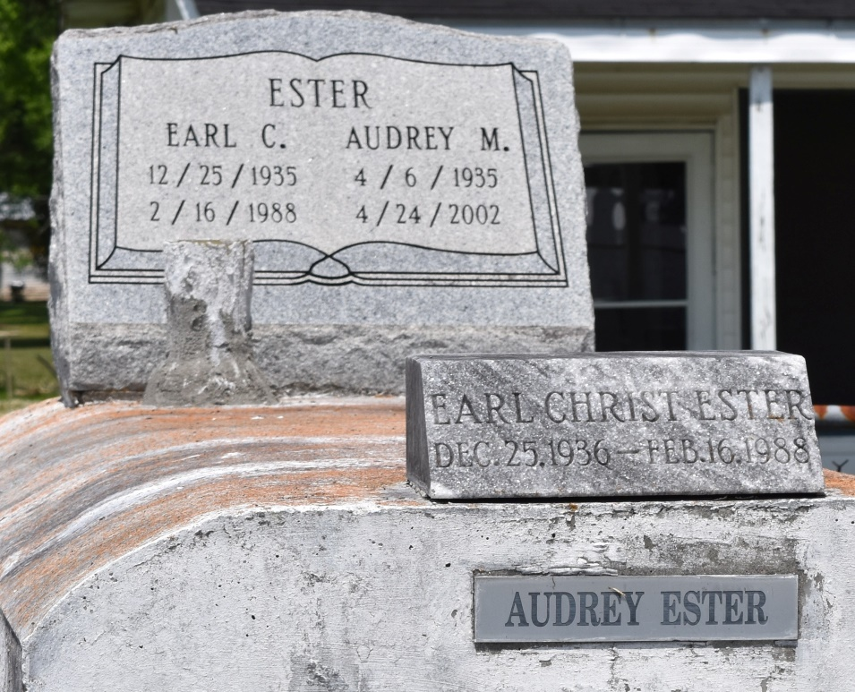

Audrey M. Johnson Ester departed this life on Wednesday, April 24, 2002 at River Parishes Hospital, LaPlace, LA. Daughter of Helen F. Millet and the late James Johnson. Stepdaughter of Joseph Millet. Wife of the late Earl Christ Ester by present marriage and by previous marriage, Almo William (Billy) Taylor. Mother of Robin M. Bailey. Sister of Rose C. Dennis of Pineville, LA, Dolores J. Martin, Clarence Variste and Elton Millet of LaPlace, LA. Also survived by: son-in-law, Veron Bailey, Sr.; two grandsons: Christian and Brett Bailey; three brothers-in-law: Victor B. Dennis, Jr., Albert Singleton and Lorey L. Martin, Jr.; five sisters-in-law: Julie C. Variste, Brenda Y. Millet, Margaret Ursin, Mary Ester and Rosetta Singleton; two uncles: Albert "Pelly" Johnson, Sr. and Steve Floyd; two aunts: Mayolia F. Brown and Catherine Floyd; a devoted friend, Margie Young; a host of other relatives and friends. Age 67 years. A native of Lutcher, LA and a resident of LaPlace, LA.  
  
Relatives and friends of the family; pastors, officers and members of Providence No. 1 B.C. and all neighboring churches are invited to attend the Funeral Service on Monday, April 29, 2002 at 10:00 a.m. from the above named Church, 240 Pine St., LaPlace, LA. Rev. Willie Smith, Pastor - officiating. Interment in Providence Rest Haven Cemetery, LaPlace, LA.  
  
Service entrusted to HOBSON BROWN FUNERAL HOME

Times-Picayune, The (New Orleans, LA) - Sunday, April 28, 2002

Contributed by Jane Edson