Cleveland Gregoire

June 20, 1943 – December 25, 2005

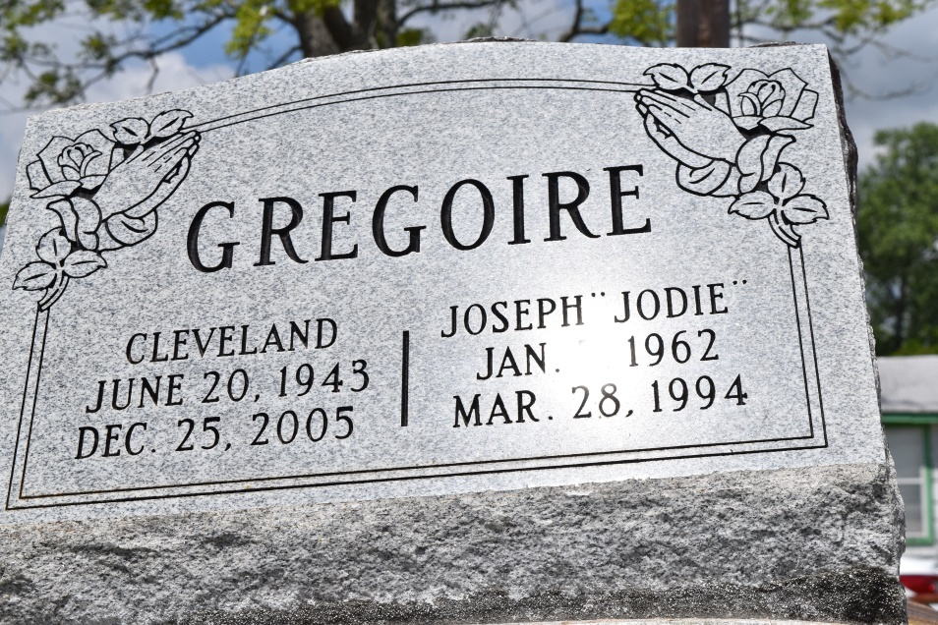

Cleveland Gregoire, of Laplace, LA at his sister's residence on Sunday, December 25, 2005 at 8:00 p.m. Son of Everlina Gregoire and the late Clayton Gregoire, Sr. Brother of Evelyn Bourgeois, Deloris Caylod, Bernice Hollins, Hattie Gregoire, Cookie Taylor, Robert, Ronnie and Walton Gregoire. Brother-in-law of Robyn, Acquanita Gregoire, Jules Hollins and Wilford Bourgeois. Preceded in death by 2 brothers, Clayton Jr., and Joseph Gregoire, 2 nephews, Tramone and Jody Gregoire. Survived by a host of nieces, nephews, cousins and friends.  
  
A native and resident of LaPlace, LA. Age 62 years.  
  
Relatives and friends of the family, also Pastor, Officers and Members of the Providence Baptist Church #2, employees of St.John Parish Sewerage and Water Board, Evangeline of Ormond, Ochsner Clinic, Canon Hospice, Kenner Regional Hospital and all neighboring churches, are invited to attend the funeral services on Saturday, December 31, 2005 at 10:00 a.m. from the Providence Baptist Church #2, Montz, LA. Rev. Donald Brown officiating. Interment Providence Rest-Haven Cemetery, Laplace, LA. Visitation at the church after 9:00 a.m.  
  
THE BALONEY FUNERAL HOME, L.L.C., 399 Earl Baloney Dr. Garyville, LA 70051.   
985-535-2540 in charge of arrangements

Times-Picayune, The (New Orleans, LA) - Friday, December 30, 2005

Contributed by Jane Edson